LANGUAGE PROCESSORS

Module 1 | Page 2
Module 2 | Page23
Module 3 | Page 56
Module 4 | Page 69
Module 5 | Page 80
Extras | Page 96

MODULE 1 - ASSEMBLERS

Language Processor

A software that bridges a specification gap or execution gap. A similar thing, called language translator, bridges an execution gap with machine language.

Semantics & Semantic gap
A semantic gap is the difference between the semantics of two domains

Semantic gap

Application Execution domain
domain

A semantic gap is tackled using software engineering steps like
1) Specification, design and coding
2) PL implementation steps .
The software implementation using the PL domain introduces the new domain called the Pl domain which comes between the application domain and the execution domain.

Specification gap Execution gap

Application PL domain Execution domain
domain

Specification gap: - It is the semantic gap between the two specifications of the same task.
Execution gap: - The gap between the semantics of programs written in the different programming languages.
Language processors: - It is a software which bridges a specification or execution gap. The input program of a language processor is a source program and the output program is the target program.The different types of language processors are
- Language translators:- Bridges an execution gap to the machine language
- assemblers- A language translator whose source language is assembly language
- compiler- A language translator whose source language is a high level language
- Detranslator:-converts machine language to assembly level language.
- Preprocessor:- Which bridges an execution gap and is not a language translator.
Eg:- Macro preprocessor
- Language migratory- bridges the specification gap between two PLs
- Interpreter:-Bridges an execution gap without generating a machine language .there is an absence of a target program. Interpreter executes each line as and when it is interpreted. Actually interpreter executes a program written in a PL .So execution gap vanishes totally.

PL domain execution
Application domain
domain
If the specification gap is more then that software system will be poor in quality and require large amount of time and effort to develop .A solution is to develop a PL which is close to the application.

Problem oriented languages
PLs used for specific application are called problem oriented languages .They are more close to the application domain.They have more execution gap and it is bridged by a translator or interpreter.

Procedure oriented languages
Provides general purpose facilities required in most application domains .Such a language is independent of specific application domains and result in large specification gap which has to be bridged by an application designer.

Language processing activities
a) Program generation activities (bridges specification gap)

Program Program in target
Program generator

specification PL

The program generator is a software system that accepts the specification of the program to be generated and generates the target PL. So, it introduces a new domain between the PL and application domains – program generation domain. Specification gap is now the gap between the application domain and the program generation domain. This gap is smaller than the gap between application and PL domains. This reduction in gap increases the reliability of the program and since the generator is closer to application domain, it is easier to write the specification of the program to be generated. The generator also bridges the gap to the PL domain. This also forms an easier platform for testing, since we just need to check the specification input to the generator. This is further enhanced by providing good diagnostic capabilities.
- Program execution- includes program translation and program execution
The translated program can be saved in a file, the saved program can be executed repeatedly .The program can be retranslated following modifications. During program interpretations it takes the source statements, determines its meaning and performs the actions which implement it. There are 2 popular models.
The translational model bridges the execution gap by translating a program written in PL, called source program, to an equivalent program in the machine or assembly language of the computer system, called target program.

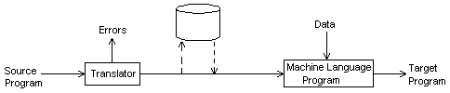

The main characteristics are:
- Program must be translated before execution.
- The program which is getting translated, as well as the translated code, may be saved for repeated execution.
- A program must be retranslated following modifications.

The second approach is the interpreter approach that reads the source program and saves it into the memory. The schematic representation is:

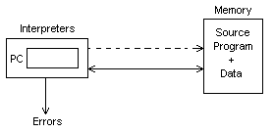
During interpretation, it takes a source statement, determines its meaning and performs actions which implement it. The working is very similar to that of a ML program by the CPU. It uses a PC to keep track of the program and subjects the instruction to 3 phases – FETCH, DECODE, EXECUTE. Likewise, in an interpreter, there are 3 phases – FETCH, ANALYSE, EXECUTE. So, the main characteristics of an interpreter are:
- Source program retained. No target program generated.
- Statement analyzed during its interpretation.

While comparing, we can see that a translation overhead exists during program translation, which changes with modifications to the source code. But, execution is efficient, since the program is in ML. But, interpreter has no such overhead. So, it can be used if a program is modified between executions (b/w testing and debugging). But it is slower than ML execution due to ML analysis.

Forward reference
The reference to an entity that precedes its definition in the program is called forward reference. An example is:
:
:
:
CALL JUMP
:
:
:
JUMP: ---
:
:
Language processor pass
It is the processing of every statement in a source program or its equivalent representation to perform a language processing function. This is also used during a set of language processing functions.

Intermediate Representation (IR)
A representation of source program, which reflects the effect of some, but not all, analysis and synthesis tasks performed during language processing.

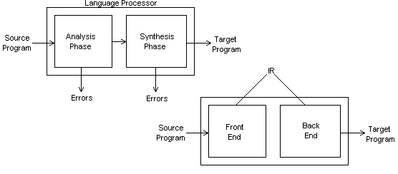

The main properties of IR are:
- Ease of use.
- Processing efficiency.
- Memory efficiency.

Assembler

Assembler is a language processor which converts assembly level language to machine level language .It is specific to a certain computer or a family of computer systems.
An assembly level statement has the following format:
[label]<opcode><operand spec>[<operand spec>…]
opcode
-called mnemonic operation codes. They specify the operation.
eg: STOP stop execution

ADD Arithmetic operation
SUB
MULT

MOVER register memory
MOVEM memory register.

COMP sets condition codes
BC Branch on condition
READ
PRINT Reading and printing.

Operand specification:-
Syntax
<symbolic name>[+<displacement>][(<index register>]
a)AREA
b) AREA+5
C) AREA(4)
d)AREA+5(4)
An assembly program consists of three kinds of statements.
1. Imperative statements:-specifies an operation to be performed.
2. Declarative:-Syntax
[label]DS<constant>
[label]DC<value>
DS is declared storage reserves areas of memory and associates name with them.
AREA DS 1
This statement reserves a memory area of 1 word and associates name AREA with it.
DC is declare constant-constructs memory word containing constants.
3.Assembler directives-a)START
b)END
c)ORIGIN
d)EQU
e)LTORG

Design specification of an assembler

There is a 4-step approach for this:
- Identify information necessary to perform a task.
- Design a suitable data structure to record the information.
- Determine the processing necessary to obtain and maintain the information.
- Determine the processing necessary to perform the task.

Based on this, the assembly process is divided into two phases- ANALYSIS, SYNTHESIS.
The primary function of the analysis phase is building the symbol table. For this, it uses the addresses of symbolic names in the program (memory allocation). For this, a data structure called location counter is used, which points to the next memory word of target program. This is called LC processing. Meanwhile, synthesis phase uses both symbol table for symbolic names and mnemonic table for the accepted list of mnemonics. Thus, the machine code is obtained. So, the functions can be given as:
Analysis phase:
- Isolate label, mnemonic opcode and operand fields of a statement.
- If a label is present, enter the pair (symbol, <LC content>) to symbol table.
- Check validity of mnemonic opcode using mnemonic table.
- Perform LC processing.
Synthesis phase:
- Obtain machine code for the mnemonic from the mnemonic table.
- Obtain address of memory operand from symbol table.
- Synthesize the machine instruction.
The phases can be represented as:

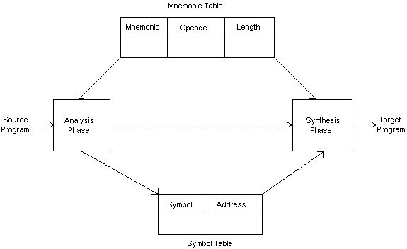
Pass structure of an assembler

A pass is defined as one complete scan of the source program, or its equivalent representation.

2-pass construction
- Easily handles forward reference.
- LC processing done first.
- 1st pass does analysis and 2nd pass does synthesis.
This process has 2 components – Symbol table as the data structure and Processed form of source program (IC).

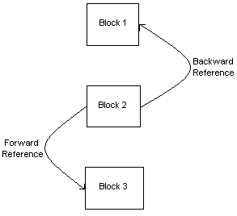

1-pass construction
- LC processing and symbol table construction proceed as in 2-pass construction.
- Problem of forward reference tackled using backpatching, where address of forward referential symbol is put into this field when the definition is encountered.

Design of a two pass assembler:-
Pass I-1.separate the symbol,mnemonic opcodes and operand fields
2.Build the symbol table.
3.Perform LC processing
4.Construct intermediate representation
Pass II-Synthesize target program.

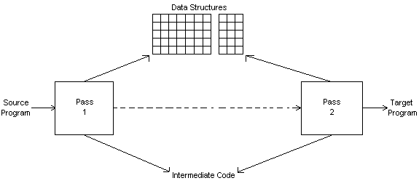

LC processing
Location counter is always incremented to contain the address of the next memory word in the target program. LC is initialized to the constant specified in the START statement.

Data structures used in pass I are
I -OPTAB (operation table)
Fields-
a)mnemonic opcode-shows the name of the instruction
b)class-shows whether instruction is imperative(IS),declarative(DL)and assembler directive(AD)
c)mnemonic info-shows the machine code and instruction length. For DL,AD statement this field contains the address of the routine which finds the length of the statement
Mnemonic opcode | Class | Mnemonic info
MOVER | IS | (04,1)
DS | DL | R#7
START | AD | R#11
STOP | AD | 00
MOVEM | IS | (05,1)
ADD | IS | (01,1)
SUB | IS | (02,1)
MULT | IS | 03
COMP | IS | 06
BC | IS | 07
DIV | IS | 08
READ | IS | 09
PRINT | IS | 10
END | AD | 02
ORIGIN | AD | 03
EQU | AD | 04
LTORG | AD | 05

II SYMTAB (symbol table)
-fields are
a) symbol-specifies the label
b) address-address of the label
c) length-length of the label
Symbol | Address | Length
LOOP | 202 | 1
NEXT | 214 | 1
LAST | 216 | 1
A | 217 | 1
BACK | 202 | 1
B | 218 | 1

III LITTAB (literal table)
-fields are
a) literals-constants
b) address-address of the literal
LITTAB collects all the literals used in the program address field will be later filled in on encountering LTORG statement

Literal | address
=’5’ | 211
=’1’ | 212
=’1’ | 219

IV POOLTAB-contains literal number of the starting literal of each literal pool. A literal pool is defined as the literals encountered since the start of the program or since the last LTORG statement.
Literal no
#1
#3
-

The various tables used by the assembler are filled during the pass1 and the output is the intermediate code .
- Algorithm for Pass1

Pass I

1.loc_cntr=0

Pooltab_ptr:=1;

POOLTAB[1]:=1;

Littab_ptr=1

2.while next statement is not an END statement

a)if label is present then

this_label:=symbol in label field

Enter(this_label,loc_cntr) in SYMTAB.

b)if an LTORG statement then

i)process literals LITTAB[POOLTAB[pooltab_ptr]]….LITTAB[littab_ptr-1] to allocate memory and put the address in the address field

Update loc_cntr

ii)pooltab_ptr=pooltab_ptr+1

iii)POOLTAB[pooltab_ptr]:=littab_ptr;

Generate IC(AD,code)( R )(C,literal)

c)if a START or ORIGIN statement then

Loc_cntr:=value specified in the operand field;

d)if an EQU statement then

i)this_addr:=value of <address spec>

ii)correct the symtab entry for this_label to(this_label,this_addr)

e)if a declarative statement then

i)code:=code of the declaration statement;

ii)size:=size of memory area required by DS/DC

iii)loc_cntr:=loc_cntr+size;

Generate IC(DL,code)(r )(C,constant/value)

f)if an imperative statement then

i)code:=machine opcode from OPTAB

ii)loc_cntr:=loc_cntr+instruction length from OPTAB;

iii)If operand is a literal then

This_literal:=literal in the operand field;

LITTAB[littab_ptr]:=this_literal;

Littab_ptr=littab_ptr+1;

This_entry=LITTAB entry no of the operand.

Generate IC(IS,code)(L,this_entry)

Else(ie operand is a symbol)

This_entry=SYMTAB entry no of the operand;

Generate IC(IS,code)(S,this_entry);

3.processing of END statement

A)perform step 2 b

B)generate IC(AD,02)

C)go to pass II

The IC generated after pass I will be of the form
(IS.04)(1)(L,01)
(IS,05)(1)(S,A)
(IS,04)(1)(S,A)
(IS,04)(3)(S,B)
(IS,01)(3)(L,02)
.
.
(IS,07)(6)(S,NEXT)
(AD,05)(C,5)
(AD,05)(C,1)
.
.
(IS,02)(1)(L,01)
(IS,07)(1)(S,BACK)
(AD,00)
(IS,03)(3)(S,B)
(DL,02)(C,1)
(DL,02)(C,1)
This code is then passed to pass 2 of the assembler which gives the machine language as the output.

Pass II

1.code_area_addr:=address of code_area;

Pooltab_ptr:=1;

Loc_cntr=0;

2.while next statement is not an END statement

A)clear machine_code_buffer

B)if an LTORG statement

i)process literals in

LITTAB[POOLTAB[pooltab_ptr]]…LITTAB[POOLTAB[pooltab_ptr+1]]-1

similar to processing of constants in a DC statement
ie,assemble the literals in the machine_code_ buffer.

ii)size :=size of memory area required for literals

iii)pooltab_ptr=pooltab_ptr+1;

C)if a START or ORIGIN statement then

i)loc_cntr:=value specified in the operand field

Ii)size=0;

D)if a declarative statement

I)if a DC statement then Assemble the constant in machine_code_buffer

Ii)size =size of memory area required by

DS/DC

E) if an imperative statement

i)get operand address from SYMTAB or LITTAB

ii)assemble instruction in machine code buffer

iii)size:=size of instruction

F) if size!=0 then

i)move contents of machine_code_buffer to the address code_area_address+loc_cntr

ii)loc_cntr=loc_cntr+size

3.processing of END statement

A)perform steps 2b and 2f

B)write code_area in to the output file.

Let the code_area_addr be equal to 2000

The machine code after pass II will be of the form
- 04 1 211
- 05 1 217
- 04 1 217
- 04 3 218
- 01 3 212
-----
-----
2210) 07 6 214
2211) 05 0 005
2212) 05 0 001
-----
2214) 02 1 219
2215) 07 1 202
2216) 00 0 000
2204) 03 3 218
2217) 02 0 001
2218) 02 0 001
- 00 0 001

Single pass translation

The problem of forward reference is tackled using a process called backpatching. The operand field of an instruction containing a forward reference is left blank initially. The address of the forward reference symbol is put in to this field when its definition is encountered.
Consider the statements
MOVER BREG,TWO
TWO DC ‘2’.
First statement can only be partially synthesized,since TWO is a forward reference.Hence the instruction opcode and address of BREG will be assembled to reside in a location<instruction address>
The need for inserting the second operands address can be indicated by creating a table of Incomplete Instructions(TII).It contains an entry of the form
(<instruction address>,<symbol>)
eg:- ( 101,TWO)
When the END statement is processed the entries from the TII are taken and address is taken from the symbol table and filled.

Macros

There can be situations where the same set of instructions get repeatedly used. Programmer can use the macro facility. Macro instructions are single line abbreviations of the group of statements. For every occurrence of the macro call the macro processor will substitute the entire block.
A macro consists of a name ,a set of formal parameters and a body of code .Consider the following set of statements

Eg:-A 1,DATA->Add the contents of DATA to register 1
A 2,DATA->Add the contents of DATA to register 2
A 3,DATA->Add the contents of DATA to register 3

Macro definition
A macro definition is formed in the following manner
MACRO<macro name><formal parameters>
macro instruction
MEND

Syntax of formal parameters:-
&<parameter name>[<parameter kind>]

Syntax of macro call
<macro name><actual parameters>

For the above program macro definition can be written as
MACRO
INCR &ARG
A 1,&ARG
A 2,&ARG
A 3,&ARG
MEND
Positional parameters
They are written in the form &< parameter name>
The value of positional formal parameter XYZ is determined by the rule of positional association as follows.
a) Find the ordinal position of XYZ in the list of formal parameter in the macro prototype statement.
b) Find the actual parameter specification occupying the same ordinal position in the list of actual parameters in the macro call statement.
Eg:-
Consider the following macro
MACRO
INCR &MEM_VAL, &INCR_VAL, &REG
MOVER &REG ,&MEM_VAL
ADD &REG ,&INCR_VAL
MOVEM &REG ,&MEM_VAL
MEND
For the macro call
INCR A, B, AREG according to the rule of positional association the values of formal parameters (actual) are
Formal parameter value
MEM_VAL A
INCR_VAL B
REG AREG

Keyword parameters
It is of the form < formal parameter name > =< ordinary string>
The value of the formal parameter XYZ is determined by the rule of keyword association as follows
1) Find the actual parameter specification which has to the form XYZ= < ordinary string>
2) Let the <ordinary string > in the specification be the string ABC.
The value of the formal parameter XYZ is ABC.
Eg:-
MACRO
INCR_M & MEM_VAL=, &INCR_VAL=, &REG=
MOVER &REG,&MEM_VAL
ADD &REG ,&INCR_VAL
MOVEM &REG,&MEM_VAL
MEND
The following calls are now equivalent
- INCR_M MEM_VAL=A, INCR_VAL=B, REG=AREG.
- INCR_M INCR_VAL=B, MEM_VAL= A, REG= AREG
Default specification of parameters
A default is a standard assumption in the absence of an explicit specification by the programmer.
Consider the call
INCR-D MEM_VAL =A, INCR_VAL=B
Here the 3rd argument is not given. So the default value AREG is used.
Macros with mixed parameter list
A macro may be defined to use both positional and keyword parameters .In such a case all the positional parameter must precede all keyword parameters
Eg:-
SUMUP A,B,G=20,H=X
A,B are positional parameters
G,H are keyword parameters.

Conditional macro expansion:-

AIF and AGO
Consider the example
A 1,DATA 1
A 2,DATA 2
A 3,DATA 3;
.
;
;
A 1,DATA 3
A 2,DATA 2
.
.
.
A 1,DATA1
DATA1 DC ‘5’
DATA2 DC ‘10’
DATA3 DC ‘15’
Here the operands and the no of arguments change
So this can be written as
MACRO
VARY &COUNT,&ARG1,&ARG2,&ARG3
A 1,&ARG1
AIF(&COUNT EQ 1).FINI
A 2,&ARG2
AIF(&COUNT EQ 2).FINI
A 3,&ARG3
.FINI MEND
VARY 3,DATA1,DATA2,DATA3
.
.
.
VARY 2,DATA3,DATA2
.
.
VARY 1,DATA1
DATA1 DC ‘5’
DATA2 DC ‘10’
DATA3 DC ‘15’
The statement AIF(&COUNT EQ 1).FINI directs the macroprocessor to skip to the statement labeled .FINI if the parameter corresponding to the COUNT is 1,otherwise the macroprocessor will continue with the statement following the AIF psuedo-op.
AGO is an unconditional goto statement.labels are starting with a period( . )

Macro calls within macros:-

Consider the eg:-
MACRO
ADD1 &ARG
L 1,&ARG
A 1,=’1’
ST 1,&ARG
MEND
MACRO
ADDS & ARG1,&ARG2,&ARG3
ADD1 &ARG1
ADD1 &ARG2
ADD1 &ARG3
MEND
.
;
;
ADDS DATA1,DATA2,DATA3
Macro ADDS contains calls to the macro ADD1.

Macro Preprocessor
-accepts an assembly level program containing definitions and calls and translate it into an assembly program which does not contain any macro definition and macro call

Macro
preprocessor
Assembler

Macro with macro
Definitions and Target program
Macro calls

Program without macros
Macro expansion consists of
- Identify the macr calls in the program
- Determine the values of formal parameters
- Maintain the values of the expansion time variables declared in a macro
- Organize the expansion time control flow.
- Determine the values of sequencing symbols
- Perform expansion of model statement
I)Identify macro calls
A table named macro name table (MNT) is designed to hold the names of all macros defined in the program.Macro name is entered while processing the macro definition
MNT
Macroname | #PP | #KP | #EV | MDTP | KPDTP | SSTP

II)Determine the values of formal parameters.
There are 3 tables associated with parameters.
Parameter name table(PNTAB)-hold the parameter names
Parameter name

Keyword parameter default table(KPDTAB)-holds the keyword parameters and their values
Parameter name | Default value

Actual parameter table-holds the actual parameters.
APTAB
value
III) maintain the expansion time control variable.
There are two tables
EVNTAB-hold the EV variable names
EVname
EVTAB-holds the EV variable values
value

IV) Organize expansion time control flow
The body of the macro is stored in the table MDT ( macro definition table)
The counter named MEC is initialized to the first entry in MDT. It is updated after expanding a model statement.
V) Determine the values of sequencing symbols
Two tables are associated
SSNTAB
SSname
SSTAB
MDT entry

Algorithm
Initialization part of the macro definition
KPDTAB_ptr=1;
SSTAB_PTR=1;
MDT_PTR=1;
Algorithm is invoked for every macro defined in the program
Algorithm
- SSTAB_ptr=1;
PNTAB_ptr=1;
- Process the macro prototype statement and form the MNT entry
  - name = macroname;
  - For each positional parameters
  - enter parameter name in PNTAB(PNTAB-ptr)
  - PNTAB_ptr =PNTAB_ptr + 1;
  - #PP = # PP +1;
c) KPDTP = KPDTAB_ptr ;
d) For each keyword parameter name
I) Enter parameter name and default value (if any ) in the
KPDTAB[KPDTAB_ptr]
ii) Enter parameter name in PNTAB[PNTAB_ptr]
iii)KPDTAB_ptr= KPDTAB_ptr + 1
  - PNTAB_ptr = PNTAB_ptr + 1;
  - #KP = #KP + 1;
e) MDTP = MDT_ptr;
f) #EV=0;
g) SSTP := SSTAB_ptr;
3.While not the MEND statement
a) if an LCL statement then
i) Enter expansion time variable name in EVNTAB
II) #EV = #EV+1;
B) If a model statement then
i) If label field contains a sequencing symbol then
if symbol is present in SSNTAB then
q= entry number in SSNTAB;
ELSE
Enter symbol in SSNTAB[SSNTAB_ptr] + 1;

q= SSNTAB_ptr;
SSNTAB_ptr= SSNTAB_ptr + 1;
SSTAB[SSTP +q-1]:-MDT_ptr;
ii) for a parameter generate the specification (P, # n)
iii) For an expansion variable ,generate the specification (E, # m)
iv) Record the IC in MDT[MDT_ptr];
v)MDT_ ptr = MDT_ptr + 1;
c) if a preprocessor statement
i) if a SET statement
search each expansion time variable name used in the statement in
EVNTAB and generate the spec (E,#m).
ii) if an AIF or AGO statement then
if sequencing symbol used in the statement is present in SSNTAB then
q= entry number in SSNTAB;
else
enter symbol in SSNTAB[SSNTAB_ptr];
q= SSNTAB_ ptr;
SSNTAB_PTR=SSNTAB_ptr + 1;
Replace the symbol by(S,SSTP+ q-1)
iii) Record the IC in MDT[MDT_ptr];
iv) MDT_ptr = MDT_ptr + 1;
4.MEND statement
If SSNTAB_ptr = 1 ( SSNTAB is empty ) then
SSTP = 0;
Else
SSTAB_ptr = SSTAB_ ptr + SSNTAB_ ptr -1;
If #KP = 0 then KPDTP =0;

Processing a macro call

Two tables named APTAB and EVTAB are used in this algorithm .A counter named MEC is also used.
Algorithm
1. Perform initializations for the expansion of a macro
a) MEC= MDTP field of MNT entry.
b) Create EVTAB with #EV entries and set EVTAB_ptr;
c) Create APTAB with #PP + # KP entries and set APTAB_ptr.
d) Copy keyword parameter defaults fron the entries
KPDTAB[KPDTP ]…..KPDTAB[KPDTP + #KP -1] in to
APTAB[#PP +1]……APTAB[#PP +#KP].
e)Process positional parameters in the actual parameter list and copy them in to APTAB[1]…..APTAB[#PP];
f) for keyword parameters in the actual parameter list search keyword name in parameter name field of KPDTAB [KPDTP]……KPDTAB[KPDTP+#KP-1] .
Let the KPDTAB[q] contains a matching entry .Enter value of the keyword parameter in the call (if any ) in APTAB[#PP +q –KPDTP +1];
2. While statement pointed by the MEC is not an MEND statement
a) if a model statement then
i) replace operand of the form
P( #n) and (E,#m) by values in APTAB[n] and EVTAB[m] resp.
ii) output the generated statement
iii) MEC:= MEC + 1;
b)if a SET statement with the spec (E,#m) in the label filed then
- evaluate the expression in the operand field and set an appropriate value in EVTAB[m]
ii) MEC = MEC+ 1;
  - if an AGO statement with (S,#s) in the operand filed then
MEC:= SSTAB[SSTP + s-1 ];
  - if an AIF statement with (S,#s) in the operand field then
if condition in the AIF statement is true then
MEC:+ SSTAB[SSTP +s -1];
3. Exit from macro expansion

Types of macro expansion
In macro expansion, the use of a macro name with a set of actual parameters is replaced by some code generated from its body. Macro expansion is of 2 types:
Lexical expansion: Replacement of a character string by another character string during program generation. This replaces occurrences of formal parameters with actual parameters.

Semantic expansion: Generation of instructions tailored to the requirements of a specific usage. Different uses of a macro can lead to codes which differ in number, sequence and opcodes of instructions.
A macro call leads to expansion. To differentiate original program statements and the expansions, each macro statement has a ‘+’ preceding the label field. The 2 notions concerning macro expansion are:
Expansion time control flow: Determines the order in which the model statements are visited during expansion. Usually, it is sequential from START till MEND. But it can be altered using conditional expansion or expansion time loops. The flow of control during expansion is implemented using Macro Expansion Counter (MEC). The algorithm is:
1. MEC: = statement number of 1st statement following prototype statement.
2. While statement pointed to by MEC is not MEND,
(a) If model statement, then
(i) Expand the statement.
(ii) MEC : = MEC+1;
(b) else (a preprocessor statement) MEC : = new value specified in statement.
3. Exit from macro expansion.
So, MEC works just like LC in the assembler.
Lexical substitution: Generates an assembly statement form a model statement. A model statement has 3 types of statements:
- An ordinary string standing for itself.
- Formal parameter (preceded by &).
- Preprocessor variable (preceded by &).
During lexical expansion, the 1st one remains the same, but 2nd and 3rd are replaced by the actual parameters. The rules for determining the value of formal parameters depend on the kind of parameters.

3-pass structure of macro assembler
This merges the tasks of both macro preprocessor and the assembler to create a highly efficient system.

PASS I
1. Macro definition processing.
2. SYMTAB construction.

PASS II
1. Macro expansion.
2. Memory allocation and LC processing.
3. Literal processing.
4. IC generation.

PASS III
1. Target code generation.

We can integrate the 1st pass of the assembler with the preprocessor phase to get a 2-pass system.

PASS I
1. Macro definition processing.
2. Macro expansion.
3. Memory allocation, LC processing and SYMTAB construction.
4. Literal processing.
5. IC generation.

PASS II
1. Target code generation.

Here, we can see that an imbalance exists in the 2-pass method since the majority of the processes are done in Pass 1. So, usually, 3-pass construction is preferred, which has a relatively even distribution.

MODULE 2 - COMPILERS

Compiler
A compiler is a program that reads a program in one language, the source language and translates into an equivalent program in another language, the target language. Programming languages are just notations for describing computations. So, before execution, they have to be converted to the machine understandable form – the machine language. This translation is done by the compiler. The translation process should also report the presence of errors in the source program. This can be diagrammatically represented as

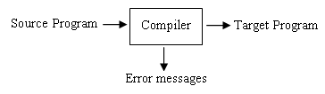
If the target program is an executable one, it can be called by the user to process inputs and produce outputs. An interpreter is similar to a compiler, except that it directly executes the program with the supplied inputs to give the output. Usually, compiler is faster than interpreter, but the interpreter has better diagnostics, since the execution is step – by – step. Java uses a hybrid compiler.
Now, let us see a generic compiler. Here, there are two parts of compilation. The analysis part breaks up the source program into constant piece and creates an intermediate representation of the source program. The synthesis part constructs the desired target program from the intermediate representation and optimizes it. Detailed structure showing the different phases of a compiler is given below.
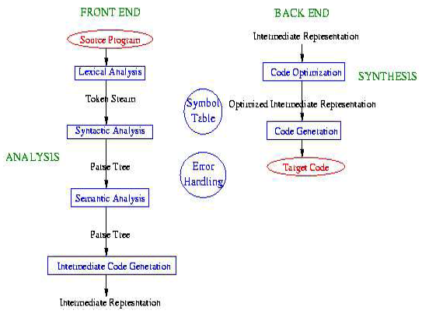
While compiling, each word of the code is separated and then converted to object code. In programming, the words are formed by:
- Keywords.
- Identifiers.
- Operators.
Now, let us see the different phases of the compiler.

Lexical Analysis
This is a linear analysis. Here, the scanner reads a character stream and converts it into a token stream. White space (space, tab, return, formfeed) and comments are ignored. Identifiers, numbers, operators, keywords, punctuation symbols etc. These tokens are the basic entities of the language. The character string associated with a token is called its Lexeme. The scanner produce error messages. It also stores the information in the symbol table.

Syntactic Analysis
This is a hierarchical analysis, also called parsing. Syntax refers to the structure or grammar of the language. The parser groups tokens into grammatical phrases corresponding to the structure of the language and a parse tree is generated. Syntactical errors are determined with the help of this parse tree.

Semantic Analysis
Semantics refers to meaning. This phase converts the parse tree into an abstract syntax tree which is less dependent on the particulars of any specific language. Parsing and the construction of an abstract syntax tree are often done at the same time. The parse is done (controlled) according to the language definition and the output of a successful parse is an equivalent abstract syntax tree. Many different languages can be parsed into the same abstract syntax, making the following phases somewhat language independent. In a typed language the abstract syntax is type checked . and an abstract syntax tree is generated corresponding to each phrase.

Intermediate Code Generation
This phase produces an intermediate representation (IT trees) a notation that isn't tied to any particular source or target language. From this point on the same compiler units can be used for any language and we can convert this to many different assembly languages. This is a program fro abstract machine and it is easy to produce and translate. Examples for intermediate codes are three address codes, postfix notations, directed acyclic graphs etc.
Code Optimization
Code optimization is the process of modifying a intermediate code to improve its efficiency.Removing redundant or unreachable codes, propagating constant values, optimizing loops etc. are some of the methods by which we can achieve this.
Code Generation
This phase generates the target code which is relocatable. Allocating memory for each variables, translating intermediate instruction into machine instruction etc. are functions of this phase.
Symbol Table
It is a data structure with a record for each identifier used in the program. This includes variables, user − defined type names, functions, formal arguments etc. Attributes of this record are Storage size, Type, Scope (visible within what language blocks), Number and types of arguments etc.Possible structures used for its implementation are Arrays, Linked Lists, Binary Search Tree and Hash Table.

Error handling
Each analysis phase may produce errors. Error messages should be meaningful. It should indicate the location in the source file. Ideally, the compiler should recover and report as many errors as possible rather than die the first time it encounters a problem.

An example showing the various phases by which an arithmetic expression translated into a machine code is given below.

pos := initial + rate * 60 (High level language statement (float rate, int initial))

id1 AssignOp id2 PlusOp id3 TimesOp integer (Token Stream produced by the scanner)

(Parse Tree produced by the parser)
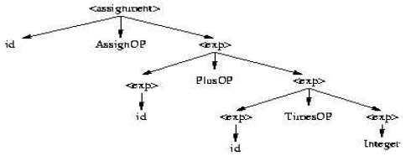

(Parse Tree produced by the Symantec Analyzer)

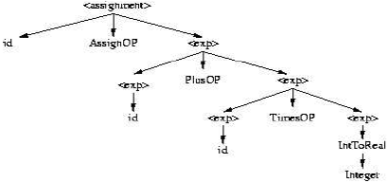

(Abstract syntax produced)

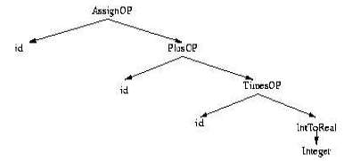

(3 address intermediate code generated)

temp1 := IntToReal(60)
temp2 := id3 * temp1
temp3 := id2 + temp2
id1 := temp3

(Optimized code generated by Code Optimizer)

temp2 := id3 * IntToReal(60)
id1 := id2 + temp2

(Target code generated by Code Generator)

movf id3, R2
mulf #60, R2
movf id2, R1
addf R2, R1
movf R1, id1

General language processing system
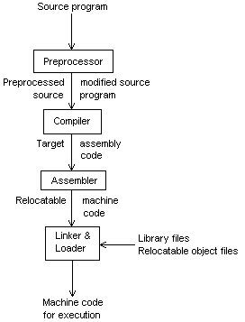

Preprocessor: A source program may be divided into modules stored in different files. The task of collecting the source program is usually entrusted to the preprocessor. In a C program, ‘#include<stdio.h>’ is a preprocessor directive that tells the preprocessor to look up stdio.h and attach it to the program. The output of the preprocessor is a preprocessed source that replaces the directives with the actual codes. It also expands macros defined by ‘#define’ to the respective statements.
Compiler: It converts the preprocessed source to target assembly code containing mnemonics like ADD, MOV, etc. Assembly code is produced since it is easy to produce and debug.
Assembler: It is a machine – dependent phase. This phase converts the assembly code to hex code, which is compatible with the architecture of the platform on which it is running. The output is relocatable that makes it compatible with different platforms. For example, consider a code: LDA 8000. But the location 8000 may not be always available. So, it is replaced with a variable to get: LDA M1, where M can be replaced with any valid available address.
Loader / Linker: Large programs are actually compiled in pieces. So, the relocatable machine code may have to be linked together with other relocatable object files and library files into the code that actually runs on the machine. The linker resolves external memory addresses, where the code in one file may refer to a location in another file. This loader then puts together all executable object files into memory for execution. It also converts the relocatable code to actual executable code by replacing the variable supplied in relocatable code to the actual memory address, based on the availability of memory.

Now, let us consider an actual compiler. The phases of an actual compiler are:

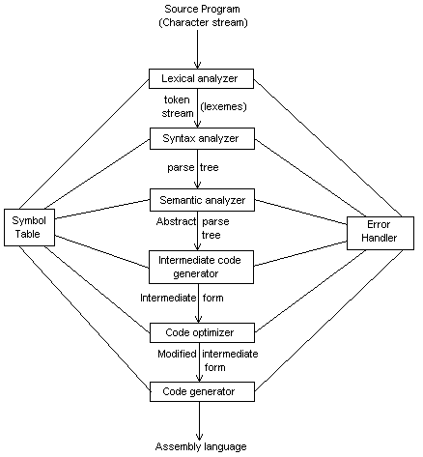

Let us see them in detail.

Lexical Analysis

This is a linear analysis. Here, the scanner reads a character stream and converts it into a sequence of symbols called lexical tokens or just tokens. White space (space, tab, return, formfeed) and comments are ignored. Identifiers, numbers, operators, keywords, punctuation symbols etc. These tokens are the basic entities of the language. The character string associated with a token is called its Lexeme. The scanner produce error messages. It also stores the information in the symbol table. The purpose of producing these tokens is usually to forward them as input to another program, such as a parser. The block diagram of a lexical analyzer is given below.
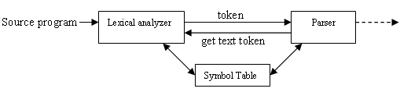

Specification of tokens

Alphabet : Finite set of symbols
eg., L = {A,B,…,Z,a,b,…z}, D = {0,1,…9}

String : Finite sequence of symbols drawn from alphabet.
eg., aba, abba, aAc

Language : Set of string over a fixed alphabet.
eg., L_{palindrome} = {awa : w {a, b}*}

Operations on languages

Consider sets, L = {A,B,…,Z,a,b,…z} and D = {0,1,…9}. Given below are some of the operations we can perform on these sets.

- LD : set of letters or digits
{s | s L or sD}

- LD : set of strings with a letter following by a digit
{st | sL , tD}

- L⁴ : set of all four letter strings

- L* : set of strings of letters, including є.
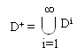

- L(LUD)* : set of all string of letters and digits beginning with a letter.

- D⁺ : set of all string of one or more digits
Regular expressions

A regular expression is a string that describes or matches a set of strings, according to certain syntax rules. Regular expressions are used by many text editors and utilities to search and manipulate bodies of text based on certain patterns. Many programming languages support regular expressions for string manipulation. For example, Perl and Tcl have a powerful regular expression engine built directly into their syntax. If r is a regular expression, then L(r) denotes the language accepting this regular expression. Following are some of the operations that we can perform on regular expressions

Alternation
A vertical bar separates alternatives.
eg., gray | grey, matches {gray, grey}

Grouping
Parentheses are used to define the scope and precedence of the operators.
eg., gr(a|e)y also matches {gray, grey}

Quantification
A quantifier after a character or group specifies how often that preceding expression is allowed to occur. The most common quantifiers are ?, *, and +.

? : The question mark indicates there is 0 or 1 of the previous expression.
eg., "colou?r" matches {color , colour}

* : The asterisk indicates there are 0, 1 or any number of the previous expression.
eg., "go*gle" matches {ggle, gogle, google, ... }

+ : The plus sign indicates that there is at least 1 of the previous expression.
eg., "go+gle" matches {gogle, google, ..} but not ggle.

Examples

1 a|b* denotes {ε, a, b, bb, bbb, ...}
2 (a|b)* denotes the set of all strings consisting of any number of a and b symbols, including the empty string
3 b*(ab*)* the same
4 ab*(c|ε) denotes the set of strings starting with a, then zero or more bs and finally optionally a c.
5 (aa|ab(bb)*ba)*(b|ab(bb)*a)(a(bb)*a|(b|a(bb)*ba)(aa|ab(bb)*ba)*(b|ab(bb)*a))* denotes the set of all strings which contain an even number of as and an odd number of bs.

Algebraic Properties

If r and s are two regular expressions. Then

r | s = s | r // Commutative
r | (s | t) = (r | s) | t // Associative
(rs)t = r(st) // Concatenation is associative
r(s | t) = rs | rt // Concatination distributes over alternation
єr = r, rє = r // є is the identity element for concatenation
r* = (r|є)*
r** = r

Regular Definitions

A regular definition gives names to certain regular expressions and uses those names in other regular expressions. Regular definitions are sequence of definitions of the form
d₁ → r₁
d₂ → r₂
.
.
d_{n} → r_{n}

where is distinct name, and each is a regular expression and symbols in єU{ d₁, d₂,.., d_{n}}

Examples
- Pascal Identifiers
letter → A | B | . . . | Z | a | b | . . . | z
digit → 0 | 1 | 2 | . . . | 9
id → letter (letter | digit)*

- Pascal numbers
digit → 0 | 1 | 2 | . . . | 9
digit → digit digit*
Optimal-fraction → . digits | ε
Optimal-exponent → (E (+ | - | ) digits) | ε
num → digits optimal-fraction optimal-exponent.

Finite State Automata

A finite state machine (FSM) or finite automaton is a model of behavior composed of states, transitions and actions. A state may or may not store information about the past, i.e. a state is just a set of coordinates when all possible coordinate values are considered. A transition indicates a state change and is described by a condition that would need to be fulfilled to enable the transition. An action is a description of an activity that is to be performed at a given moment. FSM can be represented using a state transition diagram. There are two types of finite automaton, Deterministic Finite Automata (DFA) and Non Deterministic Finite Automata (NFA).

Deterministic Finite Automata

- Developed by Robin and Scott in 1950 as a model of computer with limited memory
- It can be represented as M = (Q, Σ, δ, q_{0,} F)
where Q – set of states
Σ - i/p alphabet 1 0 1,0 a b a,b
⎡ - stack alphabet
δ - Q x Σ Q
q₀ – initial state
F – set of final states

Examples

- L = (a^{n}b : n 0}

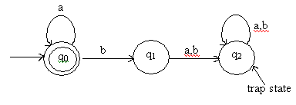

- Strings defined on {0,1}, except those containing substring 001
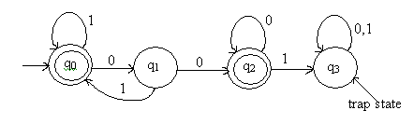

- L = { awa : w{a,b}*}
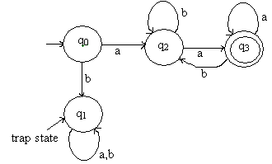

- L = {aw₁aaw₂a : w₁w₂ {a,b}*}
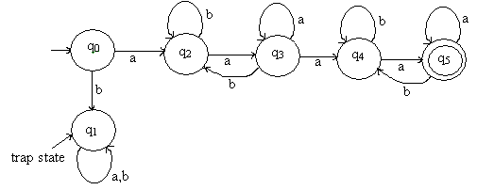

- Strings defined on {0,1}, with three consecutive zero’s
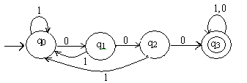

- Strings defined on {a,b}, with exactly one a.
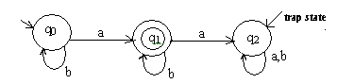

- Strings defined on {a,b}, with at least one a.
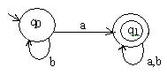

Non Deterministic Finite Automata

- Transition Function defined as δ = Q x (∑ x {}) 2^{Q}
- There can be undefined transitions.
- There can be more than one transition for a specific case

Examples
- L = {a³} {a^{2n}}
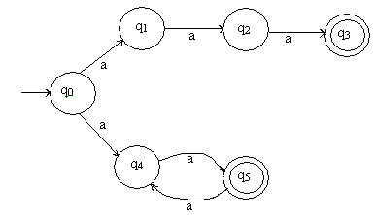

- Strings defined on {0,1} ending with 11.
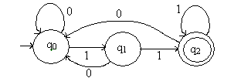

- Strings defined on {a,b} containing substring aabb
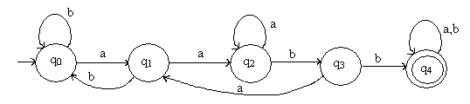

- Strings defined on {0,1}, except those containing two consecutive zero’s or one’s
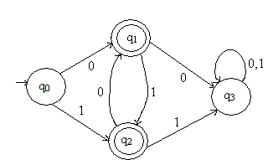

Lex

Lex is a program generator designed for lexical processing of character input streams. It accepts a high-level, problem oriented specification for character string matching, and produces a program in a general purpose language which recognizes regular expressions. The regular expressions are specified by the user in the source specifications given to Lex. The Lex written code recognizes these expressions in an input stream and partitions the input stream into strings matching the expressions. At the boundaries between strings program sections provided by the user are executed. The Lex source file associates the regular expressions and the program fragments. As each expression appears in the input to the program written by Lex, the corresponding fragment is executed.
Lex is not a complete language, but rather a generator representing a new language feature which can be added to different programming languages, called ``host languages.'' Just as general purpose languages can produce code to run on different computer hardware, Lex can write code in different host languages. The host language is used for the output code generated by Lex and also for the program fragments added by the user. Compatible run-time libraries for the different host languages are also provided. This makes Lex adaptable to different environments and different users. Input to Lex is divided into three sections, with %% dividing the sections. The structure of a lex file is as given below.

... definitions ...
%%
... rules ...
%%
... subroutines ...

Steps to compile a Lex file

- Compile lex file as
lex name.l
- Invoke the C compiler using
cc lex.yy.c -o name –ll
- Run the program as
./name < test.txt
where test.txt is the name of an input file.

Examples

- A lexer to print out all numbers in a file
%{
#include <stdio.h>
%}
%%
[0-9]+ { printf("%s\n", yytext); }
.|\n ;
%%
main()
{
yylex();
}

- A lexer to print out all HTML tags in a file.
%{
#include <stdio.h>
%}
%%
"<"[^>]*> { printf("VALUE: %s\n", yytext); }
.|\n ;
%%
main()
{
yylex();
}

- A lexer to do the word count function of the wc command in UNIX. It prints the number of lines, words and characters in a file. Note the use of definitions for patterns.
%{
int c=0, w=0, l=0;
%}
word [^ \t\n]+
eol \n
%%
{word} {w++; c+=yyleng;};
{eol} {c++; l++;}
. {c++;}
%%
main()
{
yylex();
printf("%d %d %d\n", l, w, c);
}

- Classifying tokens as words, numbers or "other".
%{
int tokenCount=0;
%}
%%
[a-zA-Z]+ { printf("%d WORD \"%s\"\n", ++tokenCount, yytext); }
[0-9]+ { printf("%d NUMBER \"%s\"\n", ++tokenCount, yytext); }
[^a-zA-Z0-9]+ { printf("%d OTHER \"%s\"\n", ++tokenCount, yytext); }
%%
main()
{
yylex();
}

- This lexer prints only words followed by punctuation. If the following sentence was the input from standard input:
"I was here", I said.
But were they? I cannot tell.
it will print the words here, said, they, and tell. It will not print the punctuation, only the words.
%{
#include <stdio.h>
%}
%%
[a-zA-Z]+/[,;:".?!] { printf("Found: %s\n", yytext); }
.|\n ;
%%
main()
{
yylex();
}

Syntax Analysis

Syntax analysis is a process in compilers recognizes the structure of programming languages. It is also known as parsing. After lexical analysis, it is much easier to write and use a parser, as the language is far simpler. Context-free grammar is usually used for describing the structure of languages and BNF notation is typical to define that grammar. Programs or code that do parsing are called parsers. A parser
- Detects and reports any syntactical errors
- Collect information into symbol table
- Produce a parse tree from which intermediate code can be generated

The block diagram of syntax analysis is given below.
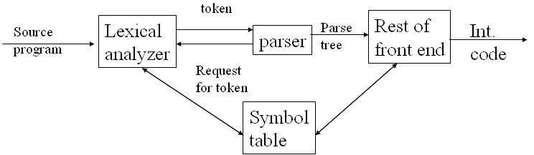

1.2.1 Context free grammars

Context-free grammars (CFG) is a formal grammar of the form
G = (N, T, P, S)
where
N – Finite set of non-terminal symbols
T – Finite set of terminal symbols
P – Productions of the form
x → a
where a (V U T)* and x V.
S – Distinguished symbol in N and is called start symbol

A formal language is context-free if there is a context-free grammar that generates it. Context-free grammars are powerful enough to describe the syntax of most programming languages; in fact, the syntax of most programming languages are specified using context-free grammars. On the other hand, context-free grammars are simple enough to allow the construction of efficient parsing algorithms which, for a given string, determine whether and how it can be generated from the grammar.
BNF (Backus-Naur Form) is the most common notation used to express context-free grammars.

Parse trees and Derivations
A parse tree or concrete syntax tree is a tree that represents the syntactic structure of a string according to some formal grammar. Given an expression and some rules, a corresponding parse-tree can be drawn. If the leaves of the trees are traversed from left to right, then the expression from which the tree was generated can be found. The leaves contain the terminal symbols, and the internal nodes contain the non-terminal symbols. For example, consider a grammar with production rules as given below.

E -> E OP E | (E) | -E | num
OP -> + | - | * | ÷

Here there are just two non-terminals, E and OP (where E is the start symbol), and seven terminal symbols: +, -, *, ÷, (, ), num. Suppose the lexical analysis phase has given us the sequence of tokens which correspond to: “(num + num) ÷ num”. The parse tree will be as given below.
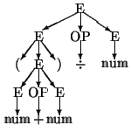

A grammar that produces more than one parse tree for some sentence is said to be ambiguous. Given below are parse trees for the input “id+id*id”
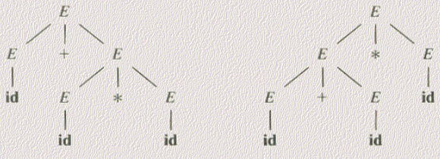

A derivation is a sequence of lines starting with the start symbol and finishing with a sequence of tokens. We get from one line to the next by applying a production rule. The lines in-between consists of a mixture of terminals and non-terminals, and are called sentential forms. For the above example we can construct a derivation of this as follows:
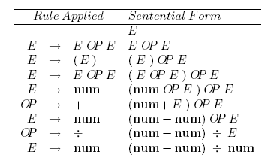
We say that E derives the sentence “(num + num) ÷ num”, and write E (num + num) ÷ num.

In top-down parsing we start with the start symbol and apply the production rules (replacing l.h.s. with r.h.s.) until we derive the sentence. With bottom-up parsing we start with the sentence, and apply the production rules in reverse (i.e. replacing r.h.s. of the rule with the l.h.s.) until we derive the start symbol. We can represent any derivation graphically by means of a parse tree. The root of the tree is the start symbol E, and its leaves are the terminal symbols in the sentence which has been derived. Each internal node is labeled with a non-terminal, and the children are the symbols obtained by applying one of the production rules.

At any stage during a parse, when we have derived some sentential form (that is not yet a sentence) we will potentially have two choices to make:
1. which non-terminal in the sentential form to apply a production rule to
2. which production rule for that non-terminal to apply

In the above example, when we derived E OP E, we could then have applied a production rule to any of these three non-terminals, and would then have had to choose among all the production rules for either E or OP. There we read the input string from left to right and derived the leftmost terminal of the resulting sentence as soon as possible. This is called the leftmost derivation.

If we want to do apply the production rules in reverse to the leftmost symbols; thus we are performing a rightmost derivation in reverse. A rightmost derivation would look like:
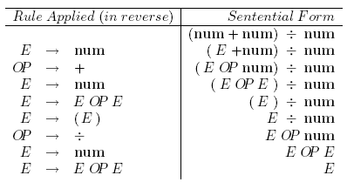
A parse tree is a graphical representation of the derivation that filters out the order in which productions are applied to replace non-terminals. A parse tree is labeled. The interior nodes are labeled by non-terminals and leaf nodes by terminals. The parse tree can be traversed in preorder or postorder. Let us take an example.
Consider a simple if statement. The CFG is:
Stmt -> if_stmt | other
If_stmt -> if(exp)stmt | if(exp)stmt else stmt
Exp ->0 | 1
Now let the if statement be
If(0)arithexp1 else arithexp2;
So, the parse tree will be formed by the derivations:
Stmt => if_stmt => if(exp)stmt else stmt
=>if(0)stmt else stmt
=>if(0)arithexp1 else arithexp2
=>if(0)arithexp1 else arithexp2
So, the tree is like:

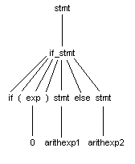
Then, the parse tree is synthesized to form the abstract syntax tree. This tree is formed by taking the terminal values of the parse tree. So, we get:
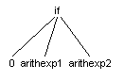
Here, if the condition (branch 1) is satisfied, branch 2 is taken (arithexp1). Else, branch 3 is taken (arithexp2). If it is only an if-else statement, we just need 2 branches. Branch 3 can be omitted.

Operator Associativity
Associativity is required to determine the order of execution of an instruction. In C, if a statement has the same operators, it is executed from left to right, and if the operators are different, it is from right to left. This can be defined using CFGs. For example, the general CFG for arithmetic expressions is like:
Exp ->exp op exp
Exp -> number
Op -> + | - | * | /
But here, we can see that we can keep on putting the 1st rule on itself. ie, infinite recursive derivation. So, Associativity is difficult to implement here. Let us see an example.
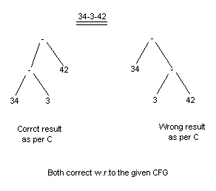
To implement Associativity, we have to eliminate the possibility of infinite recursion on one part. There are 2 associativity rules:
- Left associativity.
- Right associativity.
In left associativity, the execution is from left to right. So, the variables to the right must stay while the left side can go on expanding. So, the syntax tree is a skewed tree. This is the CFG commonly used in programming languages. The CFG can be defined as:
Exp -> exp op term | term
Op -> + | - | * | /
Term -> number
So, we can see that the right side has to stop expanding at every step since it will eventually reach the number part, which is a non-terminal that gives a terminal on its RHS.
So, the same example would be like:
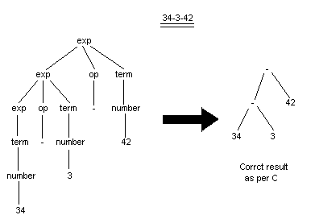
Right associativity is similar to this. Just a small change in the CFG is needed.
Now, consider the statement (3-2)+(4-3). This is actually a valid statement. But we can see that operations in parantheses are not supported by the present CFG. So, we have to modify it and bring in a controlled recursion. The CFG is modified as:
Exp -> exp op term | term
Op -> + | - | * | /
Term -> number | (exp)
Let us see the parse tree for that.
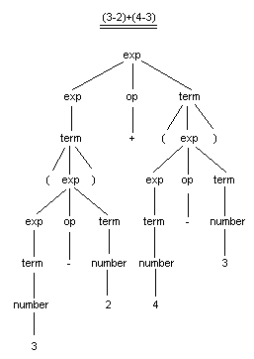
Operator precedence
This is a case that occurs while mixing different operators. In such cases, the CFGs should be well equipped to handle this. Then, the low priority operators are given at the starting production and the higher priorities as the sub productions. Let us see such a CFG.
Exp -> exp addop term | term
Addop -> + | -
Term -> term mulop factor | factor
Mulop -> * | /
Factor -> number | (exp)
Let us see examples.
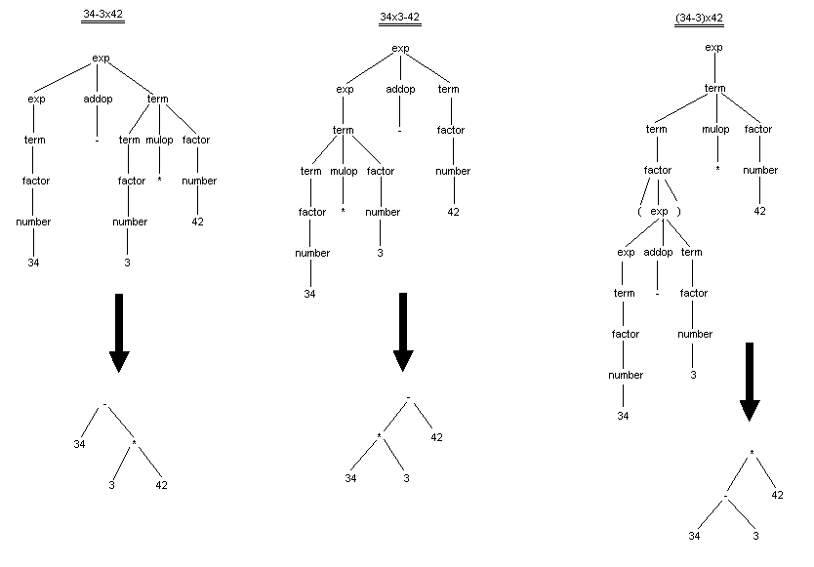
Parsing
Parsing is of 2 types:
- Top-down
- Bottom-up
Top-down Parsing
In top-down parsing we start at the most abstract level (the level of sentences) and work down to the most concrete level (the level of words). It applies each production rule to the incoming symbols by working from the left-most symbol yielded on a production rule and then proceeding to the next production rule for each non-terminal symbol encountered. In this way the parsing starts on the Left of the result side (right side) of the production rule and evaluates non-terminals from the Left first and, thus, proceeds down the parse tree for each new non-terminal before continuing to the next symbol for a production rule.
For example:
A → aBC
B → c | cd
C → df | eg
would match A → aBC and attempt to match B → c | cd next. Then C → df | eg would be tried. Some languages are more ambiguous than others. Thus in a top-down parsing we are using a leftmost derivation. For a non-ambiguous language in which all productions for a non-terminal produce distinct strings: the string produced by one production will not start with the same symbol as the string produced by another production.
Bottom-up parsing
Bottom-up parsing is a strategy for analyzing unknown data relationships that attempts to identify the most fundamental units first, and then to infer higher-order structures from them. Here, we start with the sentence and try to apply the production rules in reverse, in order to finish up with the start symbol of the grammar. This corresponds to starting at the leaves of the parse tree, and working back to the root.
- Each application of a production rule in reverse is known as a reduction.
- The r.h.s. of a rule to which a reduction is applied is known as a handle.

Consider the productions given below:
S → aABe
A → Abc | b
B → d
For a given input “abbcde” , the realization is given by
abbcde → aAbcde → aAde → aABe → S

Top-down parsing
In top-down parsing, traversal occurs from the top to leaves. At each step, the key problem is that of determining the production to be applied for a non-terminal. Once an A-production is chosen, the rest of the parsing process consists of matching the terminal symbols in the production body with the input string. This is of 2 forms:
- Backtracking
- Predictive

Backtracking involves reading the input token stream many times. So, this is a time-consuming method. So, we usually go for predictive ones.
Predictive parsers
A predictive parser is a recursive descent parser with no backtracking. Predictive parsing is possible only for the class of LL(k) grammars, which are the context-free grammars for which there exists some positive integer k that allows a recursive descent parser to decide which production to use by examining only the next k tokens of input. (The LL(k) grammars therefore exclude all ambiguous grammars, as well as all grammars that contain left recursion. Any context-free grammar can be transformed into an equivalent grammar that has no left recursion, but removal of left recursion does not always yield an LL(k) grammar.) A predictive parser runs in linear time.

To ensure that there is no backtracking, we want it to select the correct rule so that it constructs the tree without having to go back and try a different rule if the one it selects is not part of the derivation of the input sentence. In order to do this, we need to eliminate any left recursion in the grammar, since that would lead our parser to an infinite length parse. Once we have done that, we need to factor the grammar to remove common prefixes.
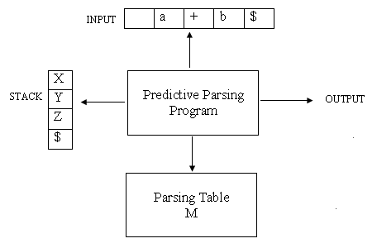
Left Recursion
A grammar is left-recursive if we can find some non-terminal ‘A’ which will eventually derive a sentential form with itself as the left-symbol.
A → Aα | β (Immediate left recursion)

A → Bα | C (Indirect left recursion)
B → Aβ | D

Removing left recursion
For each rule of the form A → Aα₁ |..| Aα_{n} | β₁ |..| β_{m}
where :
A is a left-recursive non-terminal
α is a sequence of non-terminals and terminals that is not null ()
β is a sequence of non-terminals and terminals that does not start with A.
Replace the A-production by the production :
A → β₁A’ |..| β_{m}A’
A’→ α₁A’ |..| α_{n}A’
Left Factoring
To left factor a grammar, we collect all productions that have the same left hand side and begin with the same symbols on the right hand side. We combine the common strings into a single production and then append a new non terminal symbol to the end of this new production. Finally, we create a new set of productions using this new non terminal for each of the suffixes to the common production.
For example, production rule of the form: can be left-factored into two rules of the form:
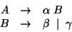
Recursive Descent parsing
It is a commonly used predictive parser. The general form of this algorithm required backtracking support, but was later modified for better efficiency. Here, the first alternative that can produce a possible tree is assumed to be the correct one. Consider an example CFG.
Exp -> term {addop term}
Addop -> + | -
Term -> factor {mulop factor}
Mulop -> *
Factor -> number
The pseudocode for this CFG is:

token; //global token variable.

main()
{
*root; //pointer to root of AST
token=readtoken();
root=exp();
}

exp()
{
*a, *b;
a=term();
while((token=='+')||(token=='-'))
switch(token)
{
case '+':match('+');
b=term();
a=treebuild('+',a,b);
break;
case '-':match('-');
b=term();
a=treebuild('-',a,b);
}
return a;
}

term()
{
*c, *d;
c=factor();
while(token=='*')
{
match('*');
d=factor();
c=treebuild('*',c,d);
}
return c;
}

factor()
{
*e;
if(token==<id>)
{
e=&token;
token=readtoken();
}
else error();
return e;
}

match(char expectedtoken)
{
if(token==expectedtoken)
token=readtoken();
else error();
}

error()
{
printf("Error!!!");
exit(1);
}
We can see that this pseudocode just represents the functions associated with each production rule.

Parsing table Construction
FIRST(X)
- If X is a terminal
FIRST(X)={X}
- If X::=Y1,Y2,c,Yk
Add FIRST(Yi) to FIRST(X) if Y1cYi-1 =>* ε
Add ε to FIRST(X) if Y1cYk =>* ε
FOLLOW(X)
- Add $ to FOLLOW(S)
- If A→ αBβ
Add everything in FIRST(β) except for ε to FOLLOW(B)
- If A→ αBβ =>* ε or A→ αB
Add everything in FOLLOW(A) to FOLLOW(B)

Consider the productions given below.
E -> E + T | T
T -> T * F | F
F -> ( E ) | num

After removing the left recursion, we get the equivalent production as
E -> TE'
E' -> TE' | ε
T -> FT'
T' -> *FT' | ε
F -> (E) | num

Then we get the parsing table as
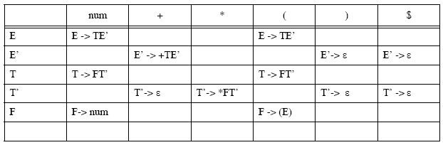

LL(1) grammars
This is another type of predictive parser. The 1st L means scanning the input from left to right and the 2nd L means producing the leftmost derivation, and the 1 for using one symbol of lookahead at each step to make parsing action decisions.
A grammar G is said to be in LL(1) iff wherever A -> x| y are 2 distinct productions of G, the following conditions hold:
- For no terminal ‘a’ do both x and y derive strings beginning with ‘a’.
- At most one of x and y can derive the empty string.
- If y=*>ε , then x doesn’t derive any string beginning with a terminal in FOLLOW(A), and vice versa.

Handles
A handle of a string ‘s’ is a substring ‘a’ such that:
- ‘a’ maches R.H.S of a production A → a
- Replace ‘a’ by L.H.S ‘A’ represents a step in the reverse of a rightmost derivation of s.

e.g.,
S → aABe
A → Abc | b
B → d
Rightmost derivation of input ‘abbcde’ is
S => aABe => aAde => aAbcde => abbcde

The string ‘aAbcde’ can be reduced in two ways:
- aAbcde => aAde
- aAbcde => aAbcBe
But (2) is not a right-most derivation. So, ‘Abc’ is the only handle.

Note: The string to the right of a handle will not contain non-terminals.

Shift Reduce parser
This uses the bottom up style of parsing. It attempts to construct a parse tree for an input string beginning at the leaves and working towards the root. It uses a stack to implement the parser. The stack is empty at the beginning of the parse and will contain the start symbol at the end of a successful parse. A bottom up parser has 2 possible actions.
SHIFT – A terminal from the front of the input to the top of the stack.
REDUCE – A string x at the top of the stack is converted to a non-terminal A such that A ->x.
The process of replacing a handle by its production rule is called handle pruning. Let us see shift reduce parser with an example. Consider the CFG:
E -> E op E
Op -> + | -
E -> id
Consider the input: id1+id2-id3. The parsing steps are:
Step | Stack | Input | Action
1 | $ | id1+id2-id3$ | Shift
2 | $id1 | +id2-id3$ | Reduce by E -> id
3 | $E | +id2-id3$ | Shift
4 | $E + | id2-id3$ | Reduce by op -> +
5 | $E op | id2-id3$ | Shift
6 | $E op id2 | -id3$ | Reduce by E -> id
7 | $E op E | -id3$ | Shift
8 | $E op E - | id3$ | Reduce by op -> -
9 | $E op E op | id3$ | Shift
10 | $E op E op id3 | $ | Reduce by E ->id
11 | $E op E op E | $ | Reduce by E -> E op E
12 | $E op E | $ | Reduce by E -> E op E
13 | $E | $ | Accept

So, we can summarize the process as follows:
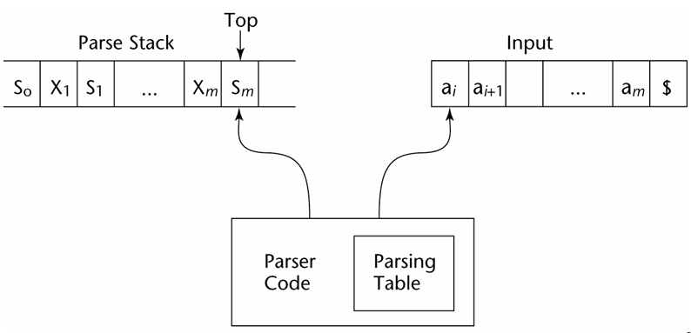
The stack is always of the form as given below.
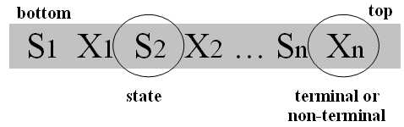
Conflicts

Shift-reduce conflict:
Can’t decide whether to shift or reduce.

e.g., Dangling else
Stmt → if Expr then Stmt
| if Expr then Stmt else Stmt
| ..
What happens when else is at the front of the input?

Reduce-reduce conflict:
Can’t decide which of several possible reductions to make.

e.g.,
Stmt → id ( params )
| Expr := Expr
| …
Expr → id ( params )
Given the input a(i,j) parameter does not know whether it is procedure call or an array reference.

LR parsers
They are table driven, like the non-recursive LL parsers. They can be constructed to recognize virtually all programming language constructs for which CFGs can be written. It is the most general non-backtracking shift reduce parser known. It can also detect a syntax error as soon as it is possible on a left-to-right scan of the input. They also can describe more languages than the LL grammars. Usually, LR parser generators are used to generate this. It is very difficult to do it by hand.
The LR parsing table consists of 2 parts – ACTION and GOTO.
ACTION – It takes as arguments a state i and a terminal a. The value of ACTION[i,a] can have one of the following forms:
- Shift j, where j is a state. It pushes a into the stack and uses j to represent it.
- Reduce the elements on the top of the stack using an available production rule to get a non-terminal.
- Accept the input and finish parsing.
- Error, which results in recovery routines.
GOTO – If GOTO[Ii,A]=Ij, then GOTO also maps a state i and a non-terminal A to state j.
So, parsing can be represented as:
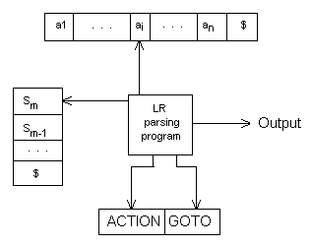
The LR(0) parsing algorithm is as follows:
INPUT: An input string w and an LR parsing table with functions ACTION and GOTO for a grammar G.
OUTPUT: If w is in L(G), the reduction steps of a bottom-up parse for w. Otherwise, an error indication.
Initially, the parser has s₀ on the stack, where s₀ is the initial state. Also, w$ is in the input buffer. The execution algorithm is:
Let a be the 1st symbol of w$;
While(1) { /*repeat forever*/
Let s be the state on top of the stack;
If(ACTION[s,a]=shift t) {
Push t onto the stack;
Let a be the next input symbol;
} else if(ACTION[s,a]=reduce A->β) {
Pop | β | symbols off the stack;
Let state t now be on top of the stack;
Push GOTO[t,A] onto the stack;
Output the production A->β;
} else if(ACTION[s,a]=accept) break; /*parsing is done*/
Else call error-recovery routine;

SLR parsing table

S’ – New start symbol.
INPUT: An augmented grammar G’.
OUTPUT: The SLR parsing table functions ACTION and GOTO for G’.
METHOD:
  - Construct C={I₀,I₁,…,I_{n}}, the collection of sets of LR(0) items for G’.
  - State i is constructed from I_{i}. The parsing actions for state i are determined as follows:
    - If [A ->α.aβ] is in I_{i} and GOTO(I_{i},a)= I_{j}, then set ACTION[i,a] to “shift j”. Here, a must be a terminal.
    - If [A ->α.] is in I_{i}, then set ACTION[i,a] to “reduce A -> α “ for all a in FOLLOW(A); here A may not be S’.
    - If [S’ -> S.] is in I_{i}, then set ACTION[i,$] to “accept”
If any conflicts occur, it is not SLR.
  - The goto transitions for state i are constructed for all non-terminals A using the rule: If GOTO(I_{i},A)= I_{j}, then GOTO[i,A]=j;
  - All entries not defined by rules (2) and (3) are made “error”.
  - The initial state of the parser is the one constructed from the set of items containing [S’ -> S].

LR(1) parsing table

INPUT: An augmented grammar G’.
OUTPUT: The canonical LR parsing table functions ACTION and GOTO for G’.
METHOD:
- Construct C’={I₀,I₁,…,I_{n}}, the collection of sets of LR(1) items for G’.
- State i is constructed from I_{i}. The parsing actions for state i are determined as follows:
    - If [A ->α.aβ,b] is in I_{i} and GOTO(I_{i},a)= I_{j}, then set ACTION[i,a] to “shift j”. Here, a must be a terminal.
    - If [A ->α.,a.] is in I_{i}, A != S’, then set ACTION[i,a] to “reduce A -> α “.
    - If [S’ -> S.,$] is in I_{i}, then set ACTION[i,$] to “accept”
If any conflict occurs, it is not LR(1).
- The goto transitions for state i are constructed for all non-terminals A using the rule: If GOTO(I_{i},A)= I_{j}, then GOTO[i,A]=j;
- All entries not defined by rules (2) and (3) are made “error”.
- The initial state of the parser is the one constructed from the set of items containing
[S’->.S,$].

LALR parsing tables

INPUT: An augmented grammar G’.
OUTPUT: The canonical LR parsing table functions ACTION and GOTO for G’.
METHOD:
- Construct C={I₀,I₁,…,I_{n}}, the collection of sets of LR(1) items.
- For each core present among the set of LR(1) items, find all sets having that core and replace these sets by their union.
- Let C’={J₀,J₁,…,J_{n}} be the resulting sets of LR(1) items. The parsing actions for state i are constructed from J_{i} in the same way as in LR(1). If any conflict occurs, it is not LALR.
- If J is the union of one or more sets of LR(1) items, ie, J=I₁ U I₂ U….U I_{K} then the cores of GOTO(I₁,X), GOTO(I₂,X),…,GOTO(I_{K},X) are the same, since I₁, I₂,….,I_{K} all have the same core. Let K be the union of all sets of items having the same core as GOTO(I₁,X). Then GOTO(J,X)=K.

Cores denote the first components of the items. LALR is used in YACC.

Yacc
Yacc is a piece of computer software that serves as the standard parser generator on Unix systems. The name is an acronym for "Yet Another Compiler Compiler." It generates a parser (the part of a compiler that tries to make sense of the input) based on an analytic grammar written in BNF notation. Yacc generates the code for the parser in the C programming language. It was developed by Stephen C. Johnson at AT&T for the Unix operating system.

Since the parser generated by Yacc requires a lexical analyzer, it is often used in combination with a lexical analyzer generator, in most cases either Lex or the free software alternative Flex. The structure of a Yacc file is as given below.

... definitions ...
%%
... rules ...
%%
... subroutines ...

Input to yacc is divided into three sections. The definitions section consists of token declarations, and C code bracketed by "%{" and "%}". The BNF grammar is placed in the rules section, and user subroutines are added in the subroutines section. When we run yacc, it generates a parser in file y.tab.c, and also creates an include file, y.tab.h

Example
A Yacc program for a simple calculator
%{
int yylex(void);
void yyerror(char *);
%}

%token INTEGER

%%

program:
program expr '\n' { printf("%d\n", $2); }
|
;
expr:
INTEGER { $$ = $1; }
| expr '+' expr { $$ = $1 + $3; }
| expr '-' expr { $$ = $1 - $3; }
| expr '*' expr { $$ = $1 * $3; }
| expr '/' expr { $$ = $1 / $3; }

;

%%
void yyerror(char *s) {
fprintf(stderr, "%s\n", s);
}

int main(void) {
yyparse();
return 0;
}

MODULE 3 – STORAGE ALLOCATION

Storage Allocation
- Specifies the amount of memory required
- It is a model to implement life time and scope
- Perform memory mapping to access non scalar values

Stack
- Linear Data Structure
- Allocation and deallocation in LIFO order
- One entry accessible at a time, through the top

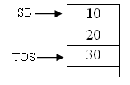
A stack holding 3 elements are given above. Here the top element is 30 pointed by the pointer TOS.

Extended Stack
Extended stack differ from a normal stack due to the following reasons.
- Entries are of different size
- Two additional pointers
    - Record base pointer (RB), points to first word of last record
    - First word in any record is a Reserved Pointer for house keeping

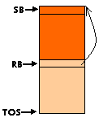

Allocation actions

Push operation
TOS = TOS + 1
TOS* = RB
RB = TOS
TOS = TOS + n

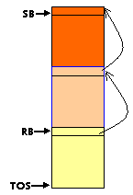

Pop operation
TOS = RB – 1
RB = RB*
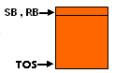

Heap
- Non Linear Data Structure
- Permits allocation and deallocation in any order

Memory
Memory is divided into code area and data area. Code area contains the program code while data area contains the data required for the program to execute. So, memory is organized as follows:
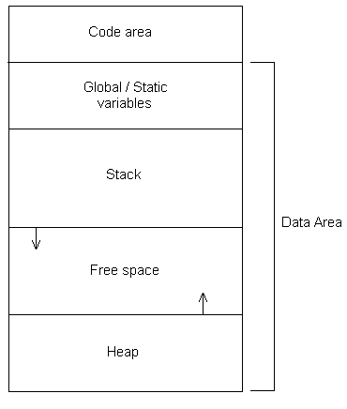
- Association between memory address attribute of data item and address of memory area
- Performs memory binding
- There are two methods of storage allocation, Static Allocation and Dynamic Allocation

Static Allocation
Allocation performed before execution, during compilation. Usually, the global and static constants and the garbage collection information are allocated statically. The main advantage is that the addresses can be incorporated into the code itself.

Dynamic Allocation
Allocation performed during execution. There are two types of dynamic execution viz., Automatic Dynamic Allocation and Program controlled Dynamic allocation.
Automatic : Allocation performed during initialization time. This uses the stack.
Program controlled : Allocation performed during execution at arbitrary points. This uses a heap. Usually, the malloc() and new statements are allocated in this way.

Function block
When a program unit or a function is entered during execution, a record is created in the stack to contain its variables. A pointer is set to point to this record. Individual variables of the program unit can be accessed using the displacements from this pointer.
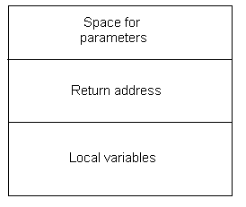

Memory allocation in block structured languages
- A block is a program segment that contains data declarations.
- There can be nested blocks
- Uses dynamic memory allocation

Scope Rules
- Declaration of a name, name_{i} creates variable var_{i}.
- Bind the name and variable using name-var binding (name_{i} , var_{i})
- Variable var_{i} created with name_{i} in block b can be accessed in block b and enclosed block b’, if b’ don’t have var_{j} with name_{i}
Consider the sample program given below.

function A()
{
int X, Y, Z;

function B()
{
int A;

function C()
{
int W,X;
}
}

function D()
{
int F;
}
}
Scope of the different variables in different functions is as given below.

Variable | function A | function B | function C | function D
X | yes | yes | yes (its local variable) | yes
Y | yes | yes | yes | yes
Z | yes | yes | yes | yes
A |  | yes | yes
W |  |  | yes
F |  |  |  | yes

Memory allocation and access
- Automatic memory allocation implemented using extended stack model with variation
- Have two reserved pointer instead of one.
- Each record is called an Activation record (AR) and it contains variables for one activation of block
- During execution Activation Record Base(ARB) points to start of TOS record
- Local variable ‘x’ can be accessed as <ARB> + d_{x}, where d_{x} is the displacement from starting point to the position where variable x is stored.
- ARB points to record currently being accessed. It stores the value of the PC and the registers such that restoration of the values are possible on returning.

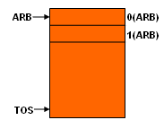

Dynamic pointer
First reserved pointer in activation record is called dynamic pointer. It points to the activation record of its dynamic parent.

Allocation actions

Push operation
TOS = TOS + 1
TOS* = ARB
ARB = TOS
TOS = TOS + 1
TOS* =
TOS = TOS + n

Pop operation
TOS = ARB – 1
ARB = ARB*

Static pointer
Second reserved pointer in activation record is called static pointer. It points to the activation record of its static ancestor. A record can have any level of ancestors.

Accessing non local variables

Algorithm
- r = ARB
- Repeat Step 3 m times
- r = 1(r)
- Access the variable as <ARB> + d_{nl_var}

Example 2.1
Consider the code fragment given below.

function A()
{
int X;
B();
}

function B()
{
int Y;
C();
}

function C()
{
int Z;
D();
}

function D()
{
int F;
}

The extended stack will be as given below.
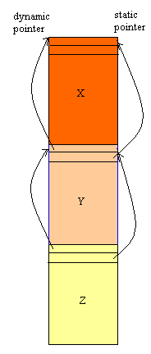

Example 2.2
Consider the code fragment given below.

function A()
{
int X;
fact(X);
}

int fact (int n)
{
if (n = = 1) return 1;
else
return n * fact(n-1);
}

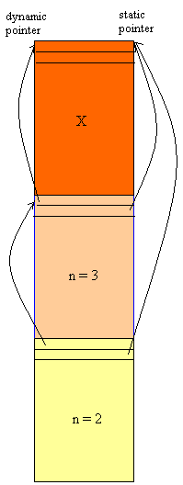

Array allocation and access
A 1-D array can be allocated as a single sequence of contiguous locations. But for a 2-D array, this is not the case. Array elements can be arranged either in row major form or in column major form. Given below is the case were elements are arranged in column major form. Consider a 2 dimensional array with m rows and n columns. Address of the element a[s₁,s₂] can be written as
Ad.a[s₁,s₂] = Ad.a[0,0] + { (s₂-0) * m + (s₁-0) } * k, where k is the amount of memory for storing a word.

If the lower limit and upper limit are l_{i} and u_{i} then we can rewrite the above formula as
Ad.a[s₁,s₂] = Ad.a[l₁, l₂] + { (s₂- l₂) * (u₁–l₁+1) + (s₁- l₁) } * k

If range_{i} represents the range of i^{th} subscript, we have
range₁ = u₁–l₁+1, range₂ = u₂–l₂+1. Then
Ad.a[s₁,s₂] = Ad.a[l₁, l₂] + { (s₂- l₂) * range₁+ (s₁- l₁) } * k
= Ad.a[l₁, l₂] – (l₂ * range₁+ l₁) * k + (s₂ * range₁+ s₁) * k
= Ad.a[0,0] + (s₂ * range₁+ s₁) * k
Hence for a matrix of order m, we can write the address as range_{j}
Ad.a[s₁,….,s_{m}] = Ad.a[0,..,0] + { ((..(s_{m}* range_{m-1}+ s_{m-1}) * range_{m-2}+ s_{m-2}) * range_{m-3}+ s_{m-3}) + …. )* range₁+ s₁} * k
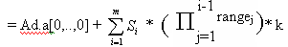
Dope vectors
An array descriptor called dope vector (DV) is used to store dimensions, lower and upper bounds and range values of the array. A dope vector is like:

Address of a[1,1,…,1]
No. of dimensions, m
l₁ | u₁ | range₁
l₂ | u₂ | range₂
l_{n} | u_{n} | range_{n}

If dimension bounds are known at compile time, DV is needed only at compilation. So, it is put into the symbol table. But if the bounds are not known (while passing array to a function), DV must exist during execution also. So, it is allocated in the activation record of the block and the displacement is stored in the symbol table.
Let us see an example code.

Int main()
{
int a[3][3];
int b[10][10];
:
:
sum(a);
:
:
sum(b);
:
:
}
int sum(int x[][])
{
int i,j;
:
:
}

So, we get:

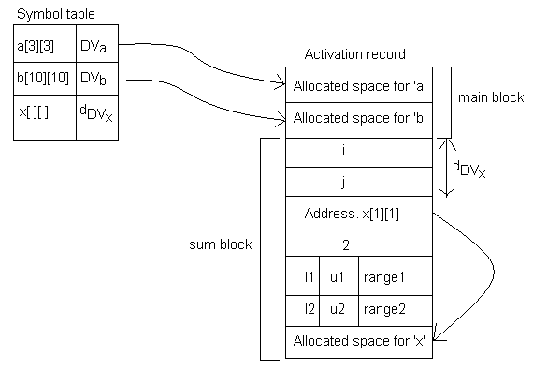
Code generation for expressions
The major issues in code generation for an expression are as follows:
- An evaluation order for the operators in an expression are required. This is usually solved using CFGs.
- Selection of instructions to be used in the target code. This depends on the type, length and addressability (memory | register | immediate) of the operand.
- Use of registers and handling partial results.
To maintain all these, we use operand descriptors. It has 2 fields:
ATTRIBUTE: Type, length and miscellaneous information.
ADDRESSABILITY: Specifies where the operand is located. It has 2 fields:
Addressability code: M = memory
R = register
AM = address of operand in memory
AR = address of operand in register
Address of memory | register code.

An operand descriptor is built for every operand participating in an expression. The considered items are:
- variables
- constants
- partial results
Let us see an example: a*b. The operand descriptor for that is:

#1 | (int,1) | a | M, addr(a)
#2 | (int,1) | b | M, addr(b)
#3 | (int,1) | a*b | R, ACCUM

So, the result is stored in the accumulator. Now, to move partial results between the memory and CPU, we use register descriptor. It has 2 fields:
STATUS: “Code-free” or “occupied” to indicate register status.
OPERAND DESCRIPTOR: If status is “occupied”, this field contains the descriptor for the operand contained in the register.
There is only one entry for each register.
An example is:

ACCUM | Code free
B | Occupied | #1

Intermediate code for expressions
This helps for easier generation of assembly code. The 3 forms are:
- Postfix
- Triples
- Quadruples

Postfix
General form of a postfix string is operators immediately after the operands

Example
Consider the expression ‘a+b*c+d*e^f’. The corresponding postfix string is ‘abc*+def^*+’. Usually, stacks are used to perform this conversion. The operand descriptors are pushed into and popped from the stack as needed. Descriptors for partial results are also used. The main advantage is that it can evaluate as well as generate the required code. But stacks are slower.

Triples
They represent elementary operations in the form of pseudo machine instructions. Each operand of the triple is either a variable or a constant or a result of some other evaluation. In the last case, the triple number is supplied.
General form of a triple is
Operator Operand1 Operand2
The expression given in the postfix example can be written in triple form as given below.
 | Operator | Operand1 | Operand2
1 | * | b | c
2 | + | 1 | a
3 | ^ | e | f
4 | * | d | 3
5 | + | 2 | 4

Indirect Triples
- It is used for optimization
- Uses Triple table and Statement table

Example
Consider the following expressions
1. z = a+b*c+d*e^f
2. y = x+b*c

The triple table and statement table for the above expressions are as given below.
This arrangement detects redundancies and eliminates the common sub expressions in a program.

Triple Table
 | Operator | Operand1 | Operand2
1 | * | b | c
2 | + | 1 | a
3 | ^ | e | f
4 | * | d | 3
5 | + | 2 | 4
6 | + | x | 1

Statement Table
Statement No. | Triple No.
1 | 1,2,3,4,5
2 | 1,6

Quadruples
They are similar to triples, except that the result has a field of its own and it is stored in a location temporarily. So, for subsequent use, the location is referred.
General form of a quadruple is
Operator Operand1 Operand2 Resultname
Here, the result name is a name. Temporary memory locations are not allocated for this. The expression ‘a+b*c+d*e^f’ can be written in quadruple form as given below.

Operator | Operand1 | Operand2 | Resultname
* | b | c | t1
+ | t1 | a | t2
^ | e | f | t3
* | d | t3 | t4
+ | t2 | t4

Expression trees
- Abstract syntax tree which shows the structure of an expression.
- Simplifies analysis of expressions to determine best evaluation order.

Consider the expression ‘(a+b)/(c+d)’. This can be evaluated in two different ways.

Method 1
MOVER AREG, A
ADD AREG, B
MOVEM AREG, temp_1
MOVER AREG, C
ADD AREG, D
MOVEM AREG, temp_2
MOVER AREG, temp_1
DIV AREG, temp_2

Method 2
MOVER AREG, C
ADD AREG, D
MOVEM AREG, temp_1
MOVER AREG, A
ADD AREG, B
DIV AREG, temp_1

To select the best evaluation method, we can use the following algorithm. The algorithm is performed as two steps. First we draw the expression tree and calculate the register required for each node without using temporary locations in the bottom up order. Then we evaluate by scanning the tree in the top down order.

Finding best evaluation method

- Associate register requirement label with each node
- Evaluate as
Visit all nodes in post order
For each node n_{i}
  - If n_{i} is a leaf node
If n_{i} is left operand RR(n_{i}) = 1
Else RR(n_{i}) = 0
  - If n_{i} is not a leaf node
If RR(l_child_{ni}) ≠ RR(r_child_{ni})
RR(n_{i}) = max(RR(l_child_{ni}), RR(r_child_{ni}))
Else
RR(n_{i}) = RR(l_child_{ni}) + 1

evaluation_order (node)
{
If node is not a leaf node
If RR(l_child_{node}) <= RR(r_child_{node}) then
evaluation_order(r_child_{node});
evaluation_order(l_child_{node});
else
evaluation_order(l_child_{node});
evaluation_order(r_child_{node});
print(node);
}

Example
Consider the expression f + (x+y) * ((a+b) / (c-d))

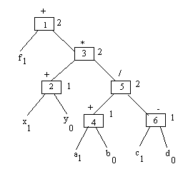

MODULE 4 - OPTIMIZATION

The target code for a compiler may be either an assembly language program or a binary code. Considered here is the case where the target code is an assembly language code.
- control transfer is implemented through conditional and unconditional goto’s
- Control structures like if, for and while introduce semantic gap between the code and the order of execution, because here control transfer is implicit, not explicit. Hence we want to map control structures to program with explicit goto’s. For this the compiler generates its own label and put against appropriate statements. Given below is the method to convert code segments with control structures like if-then-else and while loop converted into intermediate forms. This is also called ‘three address code’.

if (e) then
S₁;
else
S₂;
S₃;

if () then goto label1;
S₁;
goto lable2;
Label1: S₂;
Label2: S₃;

while (e) do
S₁;
S₂;
.
.
S_{n};
end while;
S_{n+1}

if () then goto label2;
S₁;
S₂;
.
.
S_{n};
goto lable1;
Label2: S_{n+1};

Function and Procedure calls
Side effect : Change in value of non local variables after a function call.
Actions performed when a procedure or a function call executed are summerised below.
- Actual parameters accessible in called function
- Produce side effects according to scope rule
- Control transferred and returned
- Function value returned
- All other aspects are unaffected.

Function call implementation
- Parameter list : This is a list with descriptor D_{p} for each parameter.
- Save area : Saves the content of registers before control transferred to called function and restored after return from the called function.
- Calling convention : It answerers the following questions.
  - How parameter list is accessed?
  - How save area is accessed?
  - How control transfer done?
  - How function value returned?

Calling conventions
Calling convention varies for static memory allocation and dynamic memory allocation.

Static memory:
- Parameter list and save area allocated in calling program
- An actual parameter from parameter list is accessed as
D_{p} = <r_{par_list}> + (d_{Dp})_{par_list}
Where, r_{par_list} is the register holding the address of the parameter list and hence <r_{par_list}> denotes the content of r_{par_list} register which is the address of the parameter list and (d_{Dp})_{par_list} is the displacement to where the descriptor is stored

Dynamic memory:
- Calling function construct parameter list and save area on stack. When execution inititalised, this become part of called functions activation record.
D_{p} = <ARB> + (d_{Dp})_{AR}
Where, <ARB> denotes the content of Activation record base pointer and (d_{Dp})_{AR} is the displacement to where the descriptor is stored

Parameter passing
There are basically four differed parameter passing methods. They are given below.
- Call by value
  - Value of actual parameter is copied to the corresponding formal parameter
  - On return from the function, the value of the formal parameter is not copied back to corresponding actual parameter. Hence all the changes are local to the called function.
- Call by value-name
  - Value of actual parameter is copied to the corresponding formal parameter
  - On return from the function, the value of the formal parameter is copied back to corresponding actual parameter.
- Call by reference
  - Actual parameter address is passed to called function.
  - If the parameter is an expression, it is evaluated and stored at some location and the address of that location is passed to the called function.
- Call by name
  - Every formal parameter reference inside the called function is replaced by the name of the corresponding actual parameter name. An example for this is given below.

int f1(inta, int b)
{
z = a;
i = i + 1;
b = a + 5;
}
And the function is called as f1(d[i],x);

int f1(inta, int b)
{
z = d[i];
i = i + 1;
x = d[i] + 5;
}

Code Optimization
The aim of this phase is to improve the efficiency of the program code. This is done by
- Eliminating redundancies
- Rewriting program code without changing the basic algorithm for better efficiency.
The block diagram of this phase is as given below.
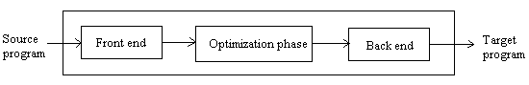

Optimizing Transformations

These are rules for writing program segment without changing the meaning or algorithm. Some common transformations are given below.

- Compile time evaluation
Performing certain things during compilation itself, without postponing till execution.
e.g., Constant folding : Operations on constant. For example program code like
x = 30/2; can be evaluated during compilation itself.

- Elimination of common sub expression
Eliminate equivalent expressions, which are the expressions yielding the same value. Consider the code segment given below.
a = b*c;
.
.
x = b*c+10;

t = b*c;
a = t;
.
.
x = t+10;
Some compilers also eliminate algebraic equivalence like what given below.
a = b*c;
d = b;
.
.
x = d*c+10;

t = b*c;
a = t;
d = b;
.
.
x = t+10;

- Dead code elimination
Codes which can be omitted without affecting the result are called dead codes. e.g., value assigned for a variable and never used there after.
Eg: while(0) { x=a+b;}

- Frequency reduction
Reduce the number of times a program code is executed. e.g., constant assignment inside a loop can be taken outside as given below. Consider the example given below.

for (i=0; i<10; i++)
{
d = b;
.
.
}

d = b;
for (i=0; i<10; i++)
{
. .
.
}

- Strength reduction
Replace time consuming operations with faster ones. e.g., multiplication operation can be replaced by repeated addition.
Eg: for(i=1; i<5; i++)
{ k=i*5; . . . }
becomes
itemp=5;
for(i=1;i<5;i++)
{ k=itemp;
itemp=itemp+5;
:
:
}

Local Optimization
- Considers small program segments with few statements
- It produce limited benefit at low cost
- Scope is basic blocks with sequential statements.

Basic block
A basic block is a sequence of program statements S₁, S₂, .., S_{n} with control transfer, if there occurs only at S_{n} and S₁ is the destination of some control transfer.
Consider the example given below.

x = a₁ + a₂;
.
.
y = a₁ + a₂;
label1: z = a₁ + a₂;

The above program segment can be divided into two basic blocks as given below.
Block1 Block2
x = a₁ + a₂; label1: z = a₁ + a₂;
.
.
y = a₁ + a₂

Value numbers
- Used to determine the occurrence of equivalent expressions in a basic block.
- Value number is the statement number of the last assignment to that variable
- To perform local optimization using value numbers perform the following
    - Add a field for value number to the symbol table
    - Add a field for a boolean variable called ‘save’ in the symbol table and set it to false
    - Represent each operand in the quadruple table as (operand, valueno.).
    - When an expression arrives, get the value of each of its operand from the symbol table, check with other quadruples in the quadruple table, if we can find a match on the operation as well as in the value number, do not enter the expression again into the symbol table but set the value of the ‘save’ variable as true. Otherwise enter the expression into the quadruple table. Consider the example given below.

- X = A+2;
- Z = X*Y;
.
.
10. W = X*Y;

Initially all the variables will have their value no. as 0 in the symbol table. Symbol table and quadruple table after executing first line is as given below.

Symbol table
Symbol | ……… | Value no.
A |  | 0
X |  | 1
Y |  | 0
Z |  | 0
W |  | 0

Quadruple table
Operator | Operand 1 |  | Operand 2 |  | Result Name | Save
Operator | Operand | Value No. | Operand | Value No. | Result Name | Save
+ | A | 0 | 2 | - | T1 | f
= | X | 0 | T1 | - | T2 | f

After executing line no.2 we have

Symbol table
Symbol | ……… | Value no.
A |  | 0
X |  | 1
Y |  | 0
Z |  | 2
W |  | 0

Quadruple table
Operator | Operand 1 |  | Operand 2 |  | Result Name | Save
Operator | Operand | Value No. | Operand | Value No. | Result Name | Save
+ | A | 0 | 2 | - | T1 | f
= | X | 0 | T1 | - | T2 | f
* | X | 1 | Y | 0 | T3 | f
= | Z | 0 | T3 | - | T4 | f

At line no.10 we have a common sub expression. Hence without making a new entry into the quadruple table we just set the value of ‘Save’ as true.

Symbol table
Symbol | ……… | Value no.
A |  | 0
X |  | 1
Y |  | 0
Z |  | 2
W |  | 10

Quadruple table
Operator | Operand 1 |  | Operand 2 |  | Result Name | Save
Operator | Operand | Value No. | Operand | Value No. | Result Name | Save
+ | A | 0 | 2 | - | T1 | f
= | X | 0 | T1 | - | T2 | f
* | X | 1 | Y | 0 | T3 | t
= | Z | 0 | T3 | - | T4 | f
.
.
= | W | 0 | T3 | - | T5 | f

Global Optimization
- More analysis required than what required in the local optimization phase
- Here we are considering the whole set of basic block as input
- Consider two basic blocks b_{i} and b_{j}. Common sub expressions can be eliminated from b_{j} if
    - b_{j} is executed only after b_{i} gets executed one or more times.
    - No assignment to any the operands happened after the evaluation of the expression in b_{i}
- Found out by using control flow and data flow analysis

Program flow graph (PFG)
The program is represented as a directed graph G_{p} = (N,E,n₀) where
N - set of basic blocks
E - directed edge (b_{i}, b_{j}) represents an edge from last statement in block b_{i} to first statement in block b_{j}
n₀ - first block

Control flow analysis
Collect information concerning program structure. e.g., loops. Some of the common terminologies are given below.
- If (b_{i}, b_{j})E, then b_{i} is called the predecessor and b_{j} the successor.
- A path is a set of edges such that the destination of one edge is the source of the other.
- If there is a path from b_{i} to b_{j}, then b_{i} is the ancestor of b_{j}
- b_{i} is the dominator of b_{j}, if all path from start node to b_{j} pass through b_{i} and b_{i} is the post dominator of b_{j}, if all path from b_{i} to the last node pass through b_{i}.

Data flow analysis
Analyze the use of data to collect information for optimization. The information collected is called data flow information.. It is computed while entering or exiting from each block.

Available expression
To eliminate the common sub expressions from a block, if the expression is available inside the block. An expression is available if
- It is evaluated in block b_{k} and b_{k} is executed at least once before reaching b_{i.}
- No assignment to any of its operands happened after the last execution of b_{k}
- No assignment to any of its operands precedes its use in b_{i}

To check the first two conditions, we calculate the availability of the expression while entering and exiting from the block.

Availability out:
Availability out is true for an expression if any of the following condition is satisfied.
- Expression is evaluated in block b_{k} and operands are not assigned a value there after.
- Expression is available while entering the block (availability in is true) and operand values are not assigned any value.

Availability in:
Availability in is true for an expression if
- Availability out is true for all its predecessor.

This can be expressed as

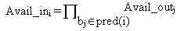

Avail_out_{i} = Eval_{i} + Avail_in_{i} Modify_{i}

Where Eval_{i} = true, if the expression is evaluated and not assigned any value for its operands there after
Modify_{i} = true, if any of the operands got modified.

Consider the program flow graph given below. Find the Avail_in and Avail_out of each block.
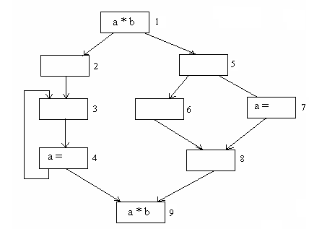

Avail_in = 2,5,6,7
Avail_out = 1,2,5,6,9

Compiler writing tools (STUDY LEX AND YACC ALSO)
The compiler writer, like any programmer, can profitably use software tools such as debuggers, version managers, profilers, and so on. In addition to the software-development tools, other more specialized tools have been developed for helping implement various phases of a compiler.
Some general tools have been created for the automatic design of specific compiler components. These tools are specialized languages for specifying and implementing the component, and may use algorithms that are quite sophisticated. The most successful tools are those that hide the details of the generation algorithm and produce components that can be easily integrated into the remainder of the compiler. Some useful compiler-construction tools are as follows:

Parser generators: These produce syntax analyzers, normally from input that is based on a CFG. In early compilers, syntax analysis consumed not only a large fraction of the running time of a compiler, but a large fraction of the intellectual effort of writing the compiler. This phase is now considered one of the easiest to implement.

Scanner generators: These automatically generate lexical analyzers, normally from a specification based on regular expressions. The basic organization of the resulting lexical analyzer is in effect, a finite automaton.

Syntax-based translation engines: These produce collections of routines that walk the parse tree, generating intermediate code. The basic idea is that one or more “translations” are associated with each node of the parse tree, and each translation is defined in terms of translations at its neighbour nodes in the tree.

Automatic code generators: Such a tool takes a collection of rules that define he translation of each operation of the intermediate language into the machine language for the target machine. The rules must include sufficient detail that we can handle the different possible access methods for data (variables may be in registers, in a fixed or static location in memory, or allocated in a stack position.). The basic technique is “template matching”. The intermediate code statements are replaced by “templates” that represent sequences of machine instructions, in such a way that the assumptions about storage of variables match from template to template. Since there are usually many options regarding where variables are to be placed (any register or the memory), there are many possible ways to “tile” intermediate code with a given set of templates, and it is necessary to select a good tiling without a combinatorial explosion in running time of the compiler. Often a high-level language especially suitable for specifying the generation of intermediate, assembly, or object code is provided by the compiler-compiler. The user writes routines in this language and, in the resulting compiler, the routines are called at the correct times by the automatically generated parser. A common feature of compiler-compiler is a mechanism for specifying decision tables that select the object code. These tables become part of the generated compiler, along with an interpreter for these tables, supplied by the compiler-compiler.

Data flow engines: Much of the information needed to perform good code optimization involves “data flow analysis”, the gathering of information about how values are transmitted from one part of the program to another part. Different tasks of this nature can be performed by essentially the same routine, with the user supplying details of the relationship between intermediate code statements and the information being gathered.

Incremental compilers
This is still an experimental concept. Usually, source codes are needed to add features. Incremental compilers allow us to add features without using the source. Her, the compiler patches up the modification code with the actual code. So, the executable is enough.

MODULE 5 – LINKERS AND LOADERS

Execution phases

The execution of a program involves 4 steps:-
- Translation – Converting source program to object modules. The assemblers and compilers fall under the category of translators.
- Linking – combines two or more separate object modules and supplies the information needed to allow references between them.
- Relocation – This modifies the object program so that it can be loaded at an address different from the location originally specified.
- Loading – which brings object program into memory for execution .It is done by a loader.

Translator
Linker
Loader
Binary program
Object modules
Binary modules
Source
Program
Data
Result
Indicate the control flow
Indicate the data flow

The translator converts the source program to their corresponding object modules, which are stored to files for future use. At the time of linking, the linker combines all these object modules together and convert them to their respective binary modules. These binary modules are in the ready to execute form. They are also stored to the files for future use. At the tine of execution the loader, uses these binary modules and load to the correct memory location and the required binary program is obtained. The binary program in turn receives the input from the user in the form of data and the result is obtained.
The loader and linker has 4 functions to perform:
- Allocation – space in memory for the program.
- Linking – resolve symbolic references. For example, consider gcc a.c –lm . Here, -lm is needed since the file math.o (precompiled) is externally linked. (since precompiled, the source cannot be taken).
- Relocation – adjuct address dependent statements with available addresses.
- Loading – load the code to memory.

Translated origin – While compiling a program P, a translator is given an origin specification for P. This is called the translated origin of P. The translator uses the value of the translated origin to perform the memory allocation for the symbols declared in P. This address will be specified by the user in the ORIGIN statement.

Execution start address: The execution start address or simply the start address of a program is the address of the instruction from which its execution must begin. The start address specified by the translator is the translated start address of the program.

Translation time (translated address) – This is the address assigned by the translator.

Linked origin – Address of the origin assumed by the linker while producing a binary program.

Linked address – This is the address assigned by the linker.

Load time (or load) address – Address assigned by the loader.

Load origin – Address of the origin assigned by the loader while loading the program for execution.

The linked and the load origin of the program may change due to the one of the two reasons:-

- The same set of translated address may have been used in different object modules constituting a program. E.g. object modules of library routines often have the same translated origins. Memory allocation to such programs would conflict unless their origins are changed.
- An operating system may require that a program should execute from a specific area of the memory. This may require a change in its origin.

The change of origin leads to change in the execution start address and in the addresses assigned to symbols.
Relocation

Program relocation: It is the process of modifying the addresses used in the address sensitive instructions of a program such that the program can execute correctly from the designated area of the memory.

Let AA be the set of absolute addresses – instruction or data addresses – used in the instructions of a program P. AA ≠ ø implies that program P assumes its instructions and data to occupy memory words with specific addresses. Such a program is called an address sensitive program.

An address sensitive instruction – It is an instruction which uses an address a (i) ε AA.

An address constant – a data word which contains an address a (i) ε AA

An address sensitive program P can execute correctly only if the start address of the memory area allocated to it is the same as its translated origin. To execute correctly from any other memory area, the address used in each address sensitive instruction of P must be ‘corrected’.

If linked origin ≠ translated origin, relocation must be performed by the linker.
If load origin ≠ linked origin, relocation must be performed by the loader.

Performing relocation

Let the translated and linked origins of program P be t_origin (p) and l_origin (p), respectively. Consider a symbol symb in P. Let its translation time be t (symb) and link time address be l (symb). The relocation factor of P is defined as

relocation_factor = l_origin (p) – t_origin (p)………… (Eq No.1)

This value can be positive, negative or zero.

Consider a statement which uses symb as an operand. The translator puts the address t (symb) in the instruction generated for it.

Now,

t (symb) = t_origin (p) + d (symb) ………………………… (Eq No.2)
where d (symb) is the offset of symb in P.

Hence
l (symb) = l_origin (p) + d (symb)

Using eq.no.1

l (symb) = t_origin (p) + relocation_factor (p) + d (symb)
= t_origin (p) + d (symb) + relocation_factor (p)
Substituting eq (2) in this,

l (symb) = t (symb) + relocation_factor (p)………………..(Eq No.3)

Let IRR (p) designate the set of instructions requiring relocation in program P. Following the Eq. 3, relocation of program P cam be performed by computing the relocation factor for P and adding it to the translation time address in every instruction i ε IRR (p).

Consider a sample assembly program, P and its generated code,

Statement Address Code
START 500
ENTRY TOTAL
EXTRN MAX, ALPHA
READ A 500) + 09 0 540

LOOP | 501)

|
MOVER AREG, ALPHA 518) + 04 1 000
BC ANY, MAX 519) + 06 6 000
|
|
BC LT, LOOP 538) + 06 1 501
STOP 539) + 00 0 000

A DS 1 540) + 00 0 000
TOTAL DS 1 541)
END

The translated origin of the program in the ex is 500.
The translation time address of symbol A is 540.

The instruction corresponding to the statement READ A (existing in the translated memory word 500) uses the address 540, hence it is an address sensitive instruction.

If the linked origin is 900, A would have the link time address 940. Hence the address in the READ instruction has to be corrected to 940.

Similarly, the instruction in translated memory word 538 contains 501, the address of LOOP. This should be corrected to 901. Same way operand address in the instructions with the addresses 518 and 519 also need to be corrected.

From the above e.g.

Relocation factor = 900 – 500 = 400

Relocation is performed as follows,

IRR (p) contains the instructions with translated addresses 500 and 538. The instruction with translated address 500 contains the address 540 in the operand field. This address is changed to (540 + 400) = 940. Similarly, 400 is added to the operand address in the instruction with the translated address 538. This achieves the relocation.

Loader schemes

The different loader schemes are:
- Compile-and -go loader
- General loading scheme
- Absolute loader

Compile-and-go loader

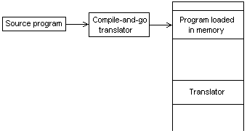
This is also called assemble-and-go loader. It is one of the easiest to implement. Her, the assembler runs in one part of the memory and places the assembled machine code, as they are assembled, directly into the assigned memory locations. So, assembler must always be present in the memory. It has 3 main disadvantages:
- A portion of the memory is wasted.
- Necessary to assemble user program everytime it is run.
- very difficult to handle multiple source files in different languages.
Turbo C uses this scheme.

General loader scheme

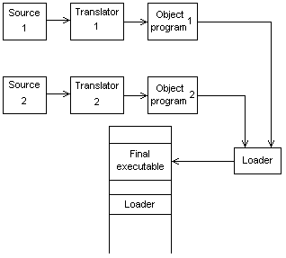

Here, different source programs are translated separately to get the respective object program. This can be the different modules of the same program also. Then, they are loaded. The loader combines the codes and executes them. Here, the object modules are saved in the secondary storage. So, the code can be loaded in the space where the assembler had been in the earlier case. But here, an extra component called loader is needed. Loader is generally smaller than the assembler. So, more space is available to the user. Also, since the object files are of the same type, we can load different types of files using this. GCC uses this scheme.

Absolute loader

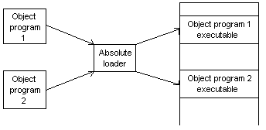

Here, the assembler outputs the machine language translation of the source program in almost the same form as in the 1st scheme. But her, the assembler is not in memory at loading time. So, more core is available to the user. They are actually, the combination of both previous schemes. The main problem is that the addresses have to be given by the user and they should not overlap.

ENTRY and EXTRN statements

Consider an application program AP consisting of a set of program units SP = {P (i)}.
A program unit P (i) interacts with another program unit P (j) using addresses of P (j)’s
instructions and data in its own instructions. To realize such interactions, P (j) and P (i) must contain public definitions and external references as defined in the following.
Public definition: a symbol pub_symb defined in a program unit which may be referenced in other program units. This is denoted with the keyword ENTRY and in the e.g. it is TOTAL.
External reference: a reference to a symbol ext_symb which is not defined in the program unit containing the reference. This is denoted with the keyword EXTRN and in the e.g it is MAX and ALPHA.
These are collectively called subroutine linkages. They link a subroutine which is defined in another program. Let us see each statement in detail.
EXTRN: EXTRN followed by a set of symbols indicates that they are defined in other programs, but referred in the present program.
ENTRY: It indicates that symbols that are defined in the present program are referred in other programs.
Let us see examples:

START
EXTERN SUBROUTE1
…….
CALL SUBROUTE1
…….
END

START
ENTRY SUBROUTE1, B2
…….
SUBROUTE1: …….
B2: ……..
END

Consider a compilation statement: gcc a.c –lm; to call sqrt( ). Here, the codes will have:
a.c => EXTERN SQRT
math.h => ENTRY SQRT

Dynamic loading
This is also called load-on-call. This is done to save memory. If all the subroutines are loaded simultaneously, a lot of space is taken up. But only one is used at a time. So, here, only the required subroutines are loaded. To identify the call sequence, we use a data structure called OVERLAY STRUCTURE. It defines mutually exclusive subroutines. So, only the ones needed are loaded and a lot of memory is saved. In order for the overlay to work, it is necessary for the module loader to load the various subroutines as they are needed. Let us see an example.
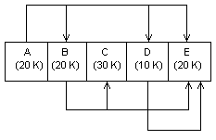

The overlay structure will be:

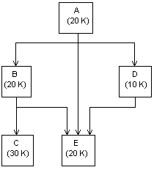

So, probable allocation is like:
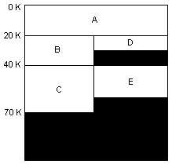
Linking

Before the application program AP can be executed, it is necessary that for each P (i) in SP, every external reference in P (i) should be bound to the correct link time address.

Linking is the process of binding an external reference to the correct link time address.

An external reference is said to be unresolved until the linking is performed for it. It is said to be resolved when its linking is completed.

Consider the program Q,

Statement Address Code
START 200
ENTRY ALPHA
|

|

ALPHA DS 25 231) + 00 0 025
END

Program unit P contains an external reference to symbol ALPHA which is a public definition in Q. The translated time address of ALPHA is 231.
Let the link origin of P be 900 and its size be 42 words.
The link origin of Q is therefore 942, and the link time address of ALPHA is 973 (942 + 31).
Linking is performed by putting the link time address of ALPHA in the instruction of P using ALPHA, i.e. by putting the address 973 in the instruction with the translation time address 518 in P.

Binary Programs

A binary program is a machine language program comprising a set of program units SP such that Pi Є SP

- Pi has been relocated to the memory area starting at its link origin, and
- Linking has been performed for each external reference in Pi.

To form a binary program from a set of object modules, the programmer invokes the linker using the command

linker < link origin >,< object module names > [,<execution start address>]

where <link origin> specifies the memory address to be given to the first word of the binary program. < execution start address > is usually a pair (program unit name, offset in program unit). The linker converts this into the linked start address. This is stored along with the binary program for use when the program is to be executed. If specification of <execution start address> is omitted the execution start address is assumed to be the same as the linked origin.

A linker converts the object modules in the set of program units SP into a binary program. Since we have assumed link address = load address, the loader simply loads the binary program into the appropriate area of the memory for the purpose of execution.

Object Module

The object module of a program contains all information necessary to relocate and link the program with other programs. The object module of a program P consists of 4 components:

- Header : The header contains translated origin, size and execution start address of P.
- Program : This component contains the machine language program corresponding to P.
- Relocation table (RELOCTAB) This table describes IRRp. Each RELOCTAB entry contains a single field.
Translated address : Translated address of an address sensitive instruction.
- Linking table (LINKTAB) This table contains information concerning the public definitions and external references in P.
Each LINKTAB entry contains three fields:
Symbol : Symbol name
Type : PD/EXT indicating whether public definition or external reference.
Translated address : For a public definition, this is the address of the first memory word allocated to the symbol. For an external reference, it is the address of the memory word which is required to contain the address of the symbol.

Program Relocation

Relocation Algorithm

a) program_linked_origin := <link origin> from linker command
b) For each object module
1.t_origin = translated origin of object module
2. OM_Size = size of the object module
3. Relocation factor = program_link_origin – t_origin
4.Read the machine language code of the program in work area.
5.Read the RELOCTAB of the object module.
c) For each entry in RELOCTAB
1) translated address = address by translator
2) address_in_work_area = address_of_work_area+ translated address – t_origin
3) Add relocation factor with the address of the operand in the memory word containing the instruction with the address, address_in _work_area.

d) Program_linked_origin = program_linked_origin + OM_Size.

Linking Requirements

References to built in functions, require linking. A name table (NAMTAB) is defined for use in program linking. Each entry of the table contains the following fields.

Symbol : symbolic name of an external reference or an object module.
Linked_address : For a public definition this field contains linked address of the symbol. For an object module, it contains the linked origin of the object module.

Most information in NTAB is derived from LINKTAB entries with type = PD.

Linkage Editors

The essential difference b/w a linkage editor and linkage loader is illustrated in this figure

Object Program(s)
Object Program(s)

Library

Library

Linking Loader
Linkage Editor
Relocating loader
Memory
Linked Program
Memory
Fig 1
Fig 2

Processing of an object program using Fig 1) Linking loader Fig 2) Linkage editor

The source program is first assembled or compiled, producing an object program (which may contain several different control sections). A linking loader performs all linking and relocation operations, including automatic library search if specified loads the linked program directly into memory for execution. A linkage editor, on the other hand, produces a linked version of the program (often called a load module or an executable image) which is written to a file or library for later execution.

When the user is ready to run the linked program, a simple relocating loader can be used to load the program into memory. The only object code modification necessary is the addition of an actual load address to relative values within the program. The linkage editor performs relocation of all control sections relative to the start of the linked program. Thus, all items that need to be modified at load time have values that are relative to the start of the linked program. This means that the loading can be accomplished in one pass with no external symbol table required. This involves much less overhead than using a linking loader.

If a program is to be executed many times without being reassembled, the use of a linkage editor substantially reduces the overhead required. Resolution of external references and library searching are only performed once( when the program is link edited). In contrast, a linking loader searches libraries and resolves external references every time the program is executed. Sometimes however, a program is reassembled for nearly every execution. This situation might occur in a program development and testing environment. It also occurs when a program is used so infrequently that it is not worthwhile to store the assembled version in a library. In such cases it is more efficient to use a linking loader, which avoids the steps of writing and reading the linked program.

The linked program produced by the linkage editor is generally in a form that is suitable for processing by a relocating loader. All external references are resolved, and relocation is indicated by some mechanism such as Modification records or bit mask. Even though all linking has been performed, information concerning external references is often retained in the linked program. This allows subsequent re-linking of the program to replace control sections, modify external references, etc. If this information is not retained, the linked program cannot be reprocessed by the linkage editor; it can only be loaded and executed.

If the actual address at which the program will be loaded is known in advance, the linkage editor can perform all of the needed relocation. The result is a linked program that is an exact image of the way he program will appear in memory during execution. The content and processing of such an image are the same as for an absolute object program.

Linkage editors can perform many useful functions besides simply preparing for an object program for execution. It can be used to build packages of subroutines or other control sections that are generally used together. This can be useful when dealing with subroutine libraries that support high level programming languages. It often allows the user to specify that external references are not to be resolved by automatic library search.

When compared to linking loaders, linkage editor in general tend to offer more flexibility and control, with a corresponding increase in complexity and overhead.

In windows, DIRECTX is the usual library. The linked program we obtain is Setup.exe. Now, when we run that file, the files are extracted and put in a folder. That folder will contain one executable (.exe) which is loaded to memory and run. Other files will also be present, that consist of different object modules.

Dynamic Linking

Linkage editors perform linking operations before the program is loaded for execution. Linking loaders perform these same operations at load time. Here a scheme that postpones the linking function until execution time is considered. A subroutine is loaded and linked to the rest of the program when it is first called. This type of function is usually called dynamic linking, dynamic loading or load on call.
Dynamic linking is often used to allow several executing programs to share one copy of a subroutine or library. For e.g., run-time support routines for a high –level language like C could be stored in a dynamic link library. A single copy of the subroutines in this library could be loaded into the memory of the computer. All C programs currently in execution could be linked to this one copy, instead of liking a separate copy into each object program.
In an object oriented system, dynamic linking is often used for references to software objects. This allows the implementation of the object and its methods to be determined at the time the program is run. The implementation can be changed at any time, without affecting the program that makes use of the object. Dynamic linking also makes its possible for one object to be shared by several programs. It also offers some other advantages over the other types of linking. Suppose a program contains subroutines that correct or clearly diagnose errors in the input data during not be used at all during most executions. If such errors are rare, the correction and diagnostic routines may not be used at all during most executions of the program. However if programs were completely linked before execution, these subroutines would provide the ability to load the routines only when they are needed. If the subroutines involved are large, or have many external references, this can result in substantial savings of time and memory space.

Dynamic loader (part of the OS)
User Program
Dynamic Loader
User Program
ERRHANDL
Library
Load-and-call ERRHANDL
Fig 3.a
Fig 3.b
Dynamic loader (part of the OS)
User Program
ERRHANDL
Fig 3.c
Dynamic loader (part of the OS)
User Program
ERRHANDL
Fig 3.d

Dynamic loader (part of the OS)
User Program
ERRHANDL
Fig 3.e
Load-and-call
ERRHANDL

Fig.3. Loading and calling of a subroutine using dynamic linking

There are a number of different mechanisms that can be used to accomplish the actual loading and linking of a called subroutine. Fig 3 illustrates a method in which routines that are to be dynamically loaded must be called via an operating system service request. This method could also be thought of as a request to a part of the loader that is kept in memory during execution of the program.

Instead of executing a JSUB instruction that refers to an external symbol, the program makes a load-and-call service request to the operating system. The parameters of this request is the symbolic name of the subroutine to be called.(See Fig 3.a) The operating system examines its internal tables to determine whether or not the routine is already loaded. If necessary, the routine is loaded from the specified user or system libraries as shown in Fig 3.b Control is then passed from the operating system to the routine being called( as in Fig 3.c)

When the subroutine completes it processing, it returns to its caller i.e. to the operating system routine that handles the load-and-call service request). The operating system then returns control to the program that issued the request. This process is illustrated in Fig 3.d
It is important that control be returned in this way so that the operating system knows when the called routine has completed its execution. After the subroutine is completed, the memory that was allocated to load it may be released and used for other purposes. However, this is not always done immediately. Sometimes it is desirable to retain the routine in memory or later use as long as the storage space is not needed for the other processing. If a subroutine is still in memory, a second call to it may not require another load operation. Control may simply be passed from the dynamic loader to the called routine as in Fig 3.e

When dynamic linking is used, the association of an actual address with the symbolic name of the called routine is not made until the call statement is executed. Another way of describing this is to say that the binding of the name to an actual address is delayed from load time until execution time. This delays binding results in greater flexibility. It also requires some overhead since the operating system must intervene in the calling process.
So, we can see that the basic feature is:
- Loader loads only the main program.
- If the main program should execute a transfer instruction to an external address, the loader is called to load the external sequence.
Advantages
- No overhead of linking the subroutine for the loader.
- System can be dynamically configured.
Disadvantages
- Complexity is very high.
Eg:
switch (input)
{ Case 1: add( );
Case 2: sub( );
Case 3: div( );
Case 4: mul( );
}
Here, only one function is needed at a time. So, depending on the case, a function call is generated and then linked to the subroutine. So, only one subroutine is present in the memory at a time.

Comparison of linking loader and linkage editor
Linking loader
- Gets a starting address from OS.
- Resolution of external symbols.
- Produce output into memory.
- Transfer control to the program.
- Used whenever a program is in a development cycle.
Linkage editors
- Absolute addresses cannot be processed.
- Produce output on disk.
- Used when program development is finished.

EXTRAS
Backpatching

The problem of forward reference is tackled using a process called backpatching. The operand field of an instruction containing a forward reference is left blank initially. The address of the forward reference symbol is put in to this field when its definition is encountered.

SDT scheme
SDT – Syntax Directed Translator. Usually uses the normal CFGs to create Intermediate Codes.
In syntax-directed translation, we attach ATTRIBUTES to grammar symbols.
The values of the attributes are computed by SEMANTIC RULES associated with grammar productions.
There are two ways to represent the semantic rules we associate with grammar symbols.
  - SYNTAX-DIRECTED DEFINITIONS (SDDs) do not specify the order in which semantic actions should be executed
  - TRANSLATION SCHEMES explicitly specify the ordering of the semantic actions.
SDDs are higher level; translation schemes are closer to
an implementation
In a SDD, each grammar production A -> α has associated with it semantic rules
b := f( c1, c2, …, ck )
where f() is a function, and either
    - b is a synthesized attribute of A, and c1, c2, …, are attributes of the grammar symbols of α, or
    - b is an inherited attribute of one of the symbols on the RHS, and c1, c2, … are attributes of the grammar symbols of α
In either case, we say b DEPENDS on c1, c2, …, ck.
Usually we actually write the semantic rules with expressions instead of functions.
If the rule has a SIDE EFFECT, e.g. updating the symbol table, we write the rule as a procedure call. When a SDD has no side effects, we call it an ATTRIBUTE GRAMMAR

Peephole optimization
Peephole optimization as a last step of a compilation sequence capitalizes on significant opportunities for removing low level code slackness left over by the code generation process. The peephole optimizer applies a set of pattern-matching rules to the code, with the goal of replacing inefficient sequences of instructions with more efficient sequences. Redundant instructions may be discarded during the final stage of compilation by using a simple optimizing technique called peephole optimization.
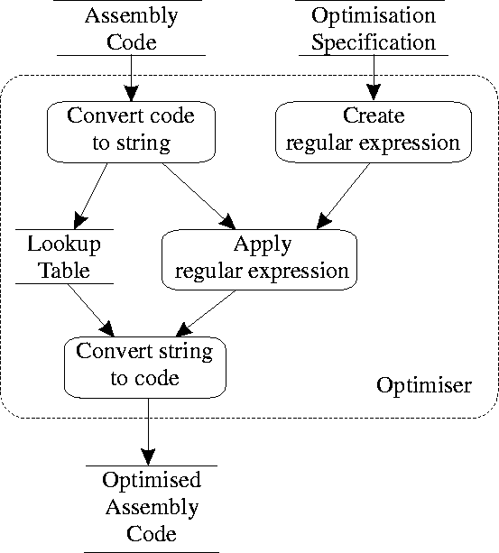
The optimizer first reads the compiler's target language output and converts all lines into strings composed of three token classes:
labels
which are converted into the character L followed by an integer identifying the label,
branch instructions
which apart from the target label are not modified, and
other code
which is replaced by the character S followed by an integer identifying that code.
A lookup table is built to convert the L and S tokens back to the original target code labels and instructions. The optimizer then reads the declarative specification of the optimizations to be performed. The specification is written as a pattern to be recognized and the replacement code.

The pattern to be recognised can consist of:
Label specifications
Names starting with L followed by digits,
Jump instructions
Written as they appear in the target code output, and
Code place-holders
For all other code represented by names starting with S followed by digits.
Sn place-holders can be followed by a trailing Kleene star (*) to specify an arbitrary number of instructions.
The replacement text is separated from the code pattern by a `=>' symbol and consists of:
New label specifications
Names starting with N followed by digits; these are replaced by unique label identifiers,
Literal output
Written as it will appear in the target code output, and
Pattern specification place-holders and labels
Names starting with S or L followed by digits; these are copied from the matched pattern.

Difference between SYMTAB and FAT
SYMTAB (symbol table)
-fields are
a) symbol-specifies the label
b) address-address of the label
c) length-length of the label
Symbol | Address | Length
LOOP | 202 | 1
NEXT | 214 | 1
LAST | 216 | 1
A | 217 | 1
BACK | 202 | 1
B | 218 | 1
FAT
- Uses Linked List Allocation
- Keep a table in memory
- One entry per block on the disk
- Each entry contains the address of the “next” block
- End of file marker (-1/EOF)
- A special value (-2) indicates the block is free
Disk size
EOF
1
Free
5
Free
7
Bad
Free
…..
3
7
5
1
0
1
2
3
4
5
6
7
File blocks
n

Context sensitive grammar
A context-sensitive grammar (CSG) is a formal grammar in which the left-hand sides and right-hand sides of any production rules may be surrounded by a context of terminal and nonterminal symbols. Context-sensitive grammars are more general than context-free grammars but still orderly enough to be parsed by a linear bounded automaton. A formal grammar G = (N, Σ, P, S) is context-sensitive if all rules in P are of the form
αAβ → αγβ
where A ∈ N (i.e., A is a single nonterminal), α,β ∈ (N U Σ)* (i.e., α and β are strings of nonterminals and terminals) and γ ∈ (N U Σ)⁺ (i.e., γ is a nonempty string of nonterminals and terminals).
In addition, a rule of the form
S → λ provided S does not appear on the right side of any rule
where λ represents the empty string is permitted. The addition of the empty string allows the statement that the context sensitive languages are a proper superset of the context free languages, rather than having to make the weaker statement that all context free grammars with no →λ productions are also context sensitive grammars.
The name context-sensitive is explained by the α and β that form the context of A and determine whether A can be replaced with γ or not. This is different from a context-free grammar where the context of a nonterminal is not taken into consideration.

Backus-Naur form
A formal language is context-free if there is a context-free grammar that generates it. Context-free grammars are powerful enough to describe the syntax of most programming languages; in fact, the syntax of most programming languages are specified using context-free grammars. On the other hand, context-free grammars are simple enough to allow the construction of efficient parsing algorithms which, for a given string, determine whether and how it can be generated from the grammar. BNF (Backus-Naur Form) is the most common notation used to express context-free grammars.

